**Manual Testing**

SDET- Software Development Engineer in Test.

Terminologies used in software industries.

Customer/ client: - he is a person who gives a requirement to the software company to get a software application for his business needs.

Example: - Swiggy owner can be a customer for one of the software company.

Software company: - it is an organization where they provide services (develop and test) for different software application needs. They receive requirements from customer or client.

REQ is requirement given by customer.it can be in the form of CRS / BRS /FS

CRS: - customer requirement specification

BRS: - business requirement specification

FS: -functional specification

Also called as REQ.

QA- quality assurance (process check)

QC- quality control (final product check

|  |  |
| --- | --- |
| QA- quality assurance (also called as verification) | QC- quality control (also called as validation) |
| process check | final product check |
| checks while process of application | qc will be done when application is ready to test. |
| Scenario writing, test case writing I part of QA | Performing different type of testing on the application is QC. |
| Example: mom checking while you are cooking is QA | Dad tasting dish after cooking is QC |

If QA is good, we will get more confidence on QC. Both QA and QC will help us in getting quality product or software application.

RTM- requirement traceability Matrix

KT- knowledge transfers

BA- business analyst. they are the people who convert CRS or BRS into SRS.

BA is person usually part of software company. BA should be very good in communication and convincing skills, technical skills and analysis skills and domain knowledge.

SRS- software requirement specification.

DOMAIN

It is categorization of software companies or application into various industries or fields.

BFSI (banking, financial services, insurance)

Companies provide those services are Infosys, TCS Capgemini, zenq

Healthcare- GE, legato, emide, Infosys, Capgemini, IBM.

Education – Byju’s , toppr

Ecommerce- amazon, Flipkart, snapdeal, myntra etc

Telecom – TCS, high radius, subex.

Travel & hospitality- cleartrip, make my trip, redbus.

Entertainment/ Gaming – EA (Electronic Arts), pole to win, gameloft

Media- Sony

Social media – FB, WhatsApp, Instagram.

Retail- wells forgo

For below interview question, use this domains and search about it in the company websites.

Before going to any company interview search about company in their website.

Q. what do you know about our company?

Q. why should we hire you in our company?

Defect: - defect is deviation in software application with respect to requirement

A defect can be either look wise or work wise. Look wise are related to front end and work wise are related to back end.

Example- if in your mail page login spelling is wrong it is look wise and if the login button is not working it is work wise.

Bug: it is informal name of the defect. Whenever test engineer raises a defect. that is accepted by developer then it is termed as bug.

Issue: -is problem faced by customer

Failure- Multiple issue faced by customer will lead to failure of company

Error: error is mistake in source code done by developers

Defect word used by test engineer

Bug, error word used by developer

Issue – customer

Failure- end user and customer

Day 3

Developer: he is person who writes the source code to develop a software application based on customer requirement.

Developer can be front end or backend developer. Front end is mainly about look of an application.

Backend is mainly about functionally.

Test Engineer: A person who test the software application given by developers based on customer requirement

End user: they are people who finally uses the application. They except a quality application.

Servers/environments: -

a computer which manages access to a centralized resource or service in a network:

server is computer with high configuration(specification) it can also be called as super computer.

Job of server is to accept the request, recognize the user and send proper response.

Request is accepted to through internet based on URL. User is recognized through IP address. Response is sent through internet again.

3 types of servers:

Development server- *(used by developers)*

QA/testing server- (*used by test engineers)*

Prod/ production server- (end users)

Example

[www.dev.facebook.com](http://www.dev.facebook.com)

[www.qa.facebook.com](http://www.qa.facebook.com)

[www.facebook.com](http://www.facebook.com)

we have the different server because developers, test engineers, end users should use the application and work independently.

When developers are working for 1 feature. That feature is given to testing team during that time developers start working for another feature.

Due to this:

1.everybody can work independently

2. dependency will not be there.

3. If any problem occurs it can be handled separately.

4.disturbance will not be there for end users.

Stake holders

A person who directly or indirectly involved in software application or project is a stake holder.

Intranet: it is network which is used to share information or access the data within an organization or company.

This is used to avoid access from external users.

**SOFTWARE DEVELOPMENT LIFE CYCLE**

It is procedure to develop the software application. It consists of different stages.

*Requirement Gathering/collection:*

Usually customer or client gives a requirement in the form of CRS or BRS. it is converted into SRS by BA. A business analyst. BA acts like bridge between customer and company.

BA should be good in

Communication skills

Domain expert

Convincing skills

Technical expert

Analysing skills

BA collect all the requirement from the customer and give to software company

This is requirement gathering/ collection

*Feasibility Study:*

In this phase BA HR, ARCHITECT, FINANCE, PM will discuss all the information that is needed

BA will explain about the project

HR is for needed resource.

Finance will take care about budget

Architect will for which technology we should use for project.

Pm will take the final decision and gathers all the data information to process for the next step or not

*Design:*

once everything is fine, we go for design. In design phase, we have HLD and LLD usually design phase is done by the architect or senior developer

HLD is like blueprint. HLD will tell about external architecture of an application

LLD is about internal architecture.

*Coding:*

once the design is done, developers starts writing the code for application by taking reference from design and customer requirement.

This is done in development server. All developers will be involved in this.

*Testing:*

Once coding is done, developers will give application to test engineers. All test engineers start testing the application and fine defect.

If any defect is found in software application, it again goes back to the developers. They will fix it and again given back to test engineers. Like this process continues, till application meets the requirement.

Once everything is completed, we will go for next phase called installation.

*Installation/Deployment:*

Making the software application for end users is called installation i.e. moving the software from testing server to production server.

It is done by the software company one testing completed. Customer/client should approve for installation.

It can be done by Installation team/ testing/ development team.

Maintenance:

Once software is provided to customers or end users, if they face any problem, a support has to be provided, that is maintenance.

Initially it will be free. Later it has to be paid.

Free service will be provided based on the agreement’s b/w customer and company.

During maintenance, defect fix will be handled and change will be taken care.

Change can be adding, modifying, deleting a feature.

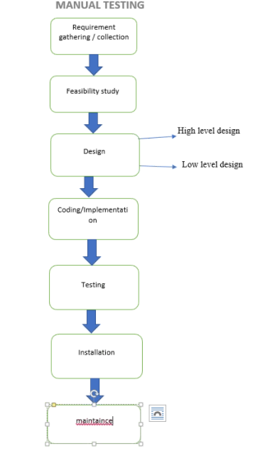

Software Testing

* Testing the functionality of an application with respect to given REQ.
* Checking the application with the intent of finding the defect.
* Checking the behaviour of an application to see whether it meets customer REQ or not
* Testing is the process of QA or QC.

Manual Testing:

Testing the software without using any tool and ensure its working fine.

Automation Testing:

Testing the software by using the tool to ensure it is working fine (example selenium)

Example

1. Television remote: if we operate by using the remote it is a automation testing if we do without remote it is manual testing.

Why testing is important?

Ans:

Every software is developed for business purpose if testing is compromised, end users may find defect while using application.

This will spread negative impact in the market and number of users who uses application will be reduced. This will become loss for the investor on business. To avoid all those thing software testing has to be done before it is release to end users.

Example: - if application like red bus is released with-out testing. I am sure all the work would be done by developers but we haven’t tested it yet. If end user takes to bus ticket and it book 1 ticket charge for 2 ticket it’s defect. this will lose faith in people of your application. Number of user will decrease. This is bad for red bus, software company.

|  |  |
| --- | --- |
| Developer | Test Engineer |
| Developer should be very Logical thinking | Creative/ out of box thinking |
| Developer always thinks to build an application | Test engineer always thinks to break an application (finding defects) |
| Usually thinking in positive angle | Should think both in positive and negative |
| Developer may think in single angle | Should think in multiple direction |
| Developer may have narrow mind | Test engineer should be broad minded |

Note: use above points to explain why you choose testing over development.

Question like: why did you choose to be test Engineer.

How will you prove you are good test engineer?

Scenario:

Testing the application in all the possible ways is scenarios.

It can be positive or negative scenarios.

Testing the application with valid or expected data is called positive scenarios. It is also called as Positive testing.

Testing the application with invalid or unexpected data is called negative scenarios. It is also called negative testing.

To identify the defect, we should find the scenarios first

Scenarios is not a defect or defect is not a scenario.

Positive and negative scenarios are not defect

Few cases we may get confused weather it is a positive or negative scenario. In this case we can judge whether is a defect or not defect based on REQ.

Note:

* while developers are developing the application, test engineer will prepare scenario and convert to test cases.
* Always remember, scenario and defect both are different.
* There can be positive scenario with a defect and positive scenario without a defect
* There can be negative scenario with a defect and without a defect.
* We should write scenarios based on requirement but to conclude defect is their or not we need application.

Testing an application in all possible way is a scenario.

Q. What test engineer do while developer developing application?

While developer developing application test engineer think about all possible scenarios and they write cases.

Assignment

Write scenario for a pen. (25 at least)/ bottle / traffic light/ fan

Interview question:

How will test a lift, write scenarios for testing lift?

(suggestion: in interview if this kind of questions are asked, ask them “do we have any specific requirement, sir?”)

REQ:

Manual operating lift

Capacity 500kg

10 floors

Fan, door, light, stop

Scenarios:

(-always write scenarios in as short sentence as possible

-Underline important word in a scenario)

Example: Verify whether door opens when you pull door?

Verify whether all the buttons present?

Verify whether all the buttons working?

Continue…

1. verify whether lift in installed properly

2. verify whether Up arrow button is there outside the lift for all floors.

3. verify whether Down arrow button is there in all floors

4. verify by pressing up arrow button

5. verify by pressing down arrow button

6. verify by pressing both UP and down arrows at time.

7. verify whether light is appearing once we press the arrow buttons.

8. verify whether Fan is installed inside the lift.

9. verify whether Fan switch is there inside the life

10. verify by turning ON the FAN when Fan is OFF.

11. Verify by turning ON FAN when Fan is ON.

12. verify by turning OFF the Fan when Fan is ON.

13. verify by turning OFF the fan when FAN is OFF.

14. verify whether light is installed inside the lift.

15. verify whether light Switch is there inside the lift.

16. Verify by turning ON the light when light is OFF.

17. Verify by turning ON light when light is ON.

18. verify by turning OFF light when light is ON.

19. verify by turning OFF the light when light is OFF.

20. verify whether we have 10 floors button to select.

21. Verify whether every button has different number on it.

22. Verify by Pressing 2nd floor button being in ground floor.

23. Verify once we press any floor button, that floor button light should be ON.

24. Verify once lift come to requested floor, it should stop automatically.

25. Verify by pressing same floor button from same floor

26. Verify whether we have STOP button inside the lift.

27. verify by pressing STOP button while lift is moving.

28. Verify by pressing STOP button while lift is Stopped

29. Verify whether doors are installed inside the lift and also outside the lift.

30. verify lift should not move if the doors are opened.

31. verify we get notification if the lift door is not closed properly.

32. Verify whether doors have handle.

33. verify by opening the door while lift is moving.

34. verify by smoking inside the lift.

35.verify by applying sanitizer for lift and button.

36.verfiy by pouring water on the button on the lift.

37. verify by powering off the electricity while lift is moving.

38. verify whether lift is moving smoothly between the floor.

39. verify whether lift is topping smoothly.

40. verify correct floor number are display in the display

41. verify by applying lesser than 500kg load and travel.

42. verify by applying equal to 500 kg load and travel.

43. verify by applying more than 500kg load and travel.

44. verify the space inside the lift.

45. Verify whether we have ventilator inside the lift.

46. verify the instruction on the lift.

47. verify whether Emergency contact number is displayed on the lift.

48 verify the brand name is proper on the lift.

49. verify by pressing al floor button at a time.

50. verify whether we space for adding additional features

………

Assignment:

Write scenarios for calculator (manual)

Write scenarios for coffee vending mechanic (require coffee, tea, and milk)

Write scenarios for slipper (write for your mother)

Solution 1:

1. Verify if calculator turns on when you press ON button.
2. Verify whether it turn on light on screen, so that we can see number which are displayed.
3. Verify if button on calculator are big enough as requested.
4. Verify whether we have 0 to 9 all buttons.
5. Verify of the button are working.
6. Verify whether we have all operators button on the cal.
7. Verify whether + is working and gives you addition.
8. Verify whether - is working and gives you subtraction.
9. Verify whether * is working and gives you multiplication.
10. Verify whether % is working and gives you division.
11. Verify whether / is working and gives you modulus.
12. Verify if it is showing solution after we press Enter.
13. Verify if we have cancelled button
14. Verify whether cancel button is working and erasing on digit at time.
15. Verify is clear button clearing off screen completely
16. Try press two buttons at same time.
17. Verify if calculator is same colour as requested.
18. Verify if all special (extra) buttons are present request like square root, square etc.
19. Verify whether calculator is turning off when we press OFF button.
20. Verify if calculator is in good condition and not broken from anywhere.

Scenario are of two types: Positive and negative

* Positive scenario with a defect
* Positive scenario without a defect
* Negative scenario with defect
* Negative scenario without defect

(always write positive scenarios first then negative.

First write workwise positive scenarios followed by look wise positive scenarios

Then workwise negative scenarios followed by look wise negative scenarios.)

Q what test Engineer do while developer developing application?

Ans: test Engineer write all possible scenarios while developer working on application.

Later those scenarios are used to create test cases.

Write scenarios for chocolate

(there is no specific requirement, your favourite)

Write scenarios for FAN (selling fan)

Write scenarios for Projector

Write scenarios for water bottle (it’s a copper water bottle)

Difference b/w scenario and test cases.

|  |  |
| --- | --- |
| Scenario | Test cases |
| It will tell all the possible ways we can test the application | It is step by step procedure to test the application |
| Scenarios says “what to do” | Test case says “how to do” |
| Scenario is high-level document | Test cases is a low- level document. |
| Scenario doesn’t have a navigation step | Test cases have a navigation step |
| Scenario doesn’t say where the exact defect | Test cases will tell where the exact defect is present |
| Scenario take less time to write | Test cases take more time to write |

Test cases:

Templates is a format used to write a test case

Test cases:

A test case is document which contain all the possible scenarios and explains step.

When do we write test cases?

when the developers are developing the application. we will write a test case.

There are two stages

1. Test case preparation/writing

2. Test case execution

Under the test case preparation, we have to fill following sections like

HEADER, BODY, FOOTER section.

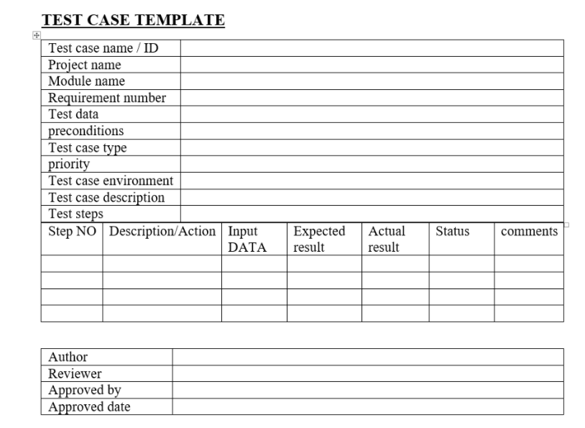

Header part

Test data: it is data we need to execute the scenarios.

per conditions: it is the action which we should do before executing the scenarios.

Test case type:

In this section we should write which type of testing we are going to use.

Priority: assigning the priority to each and every test case will help us in prioritizing the defects.

Test case description: summery of test cases.

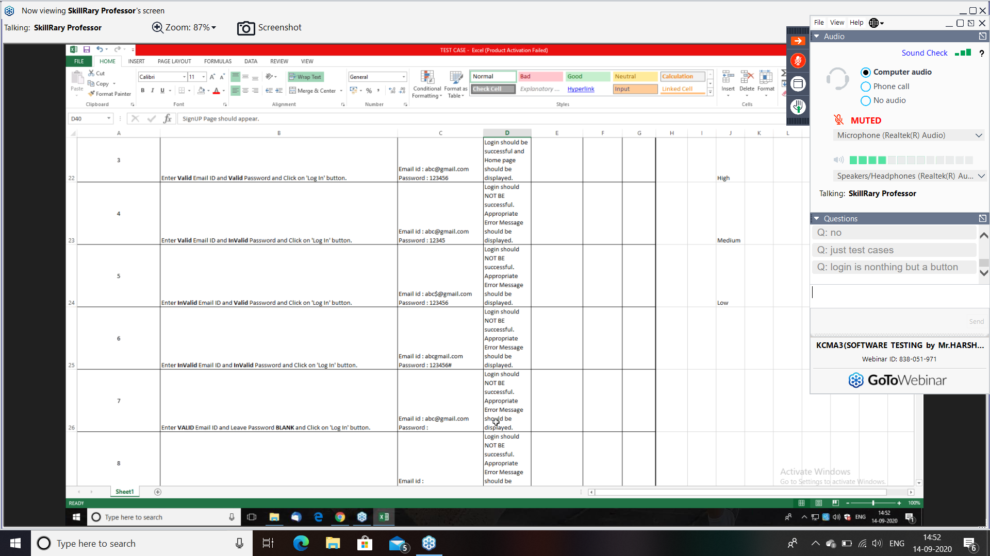

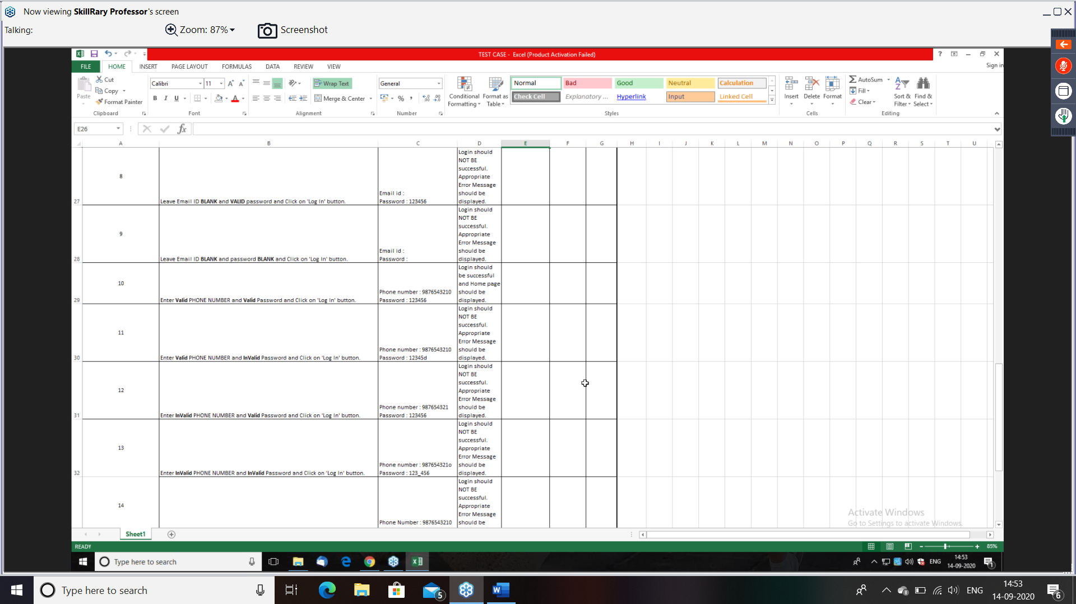

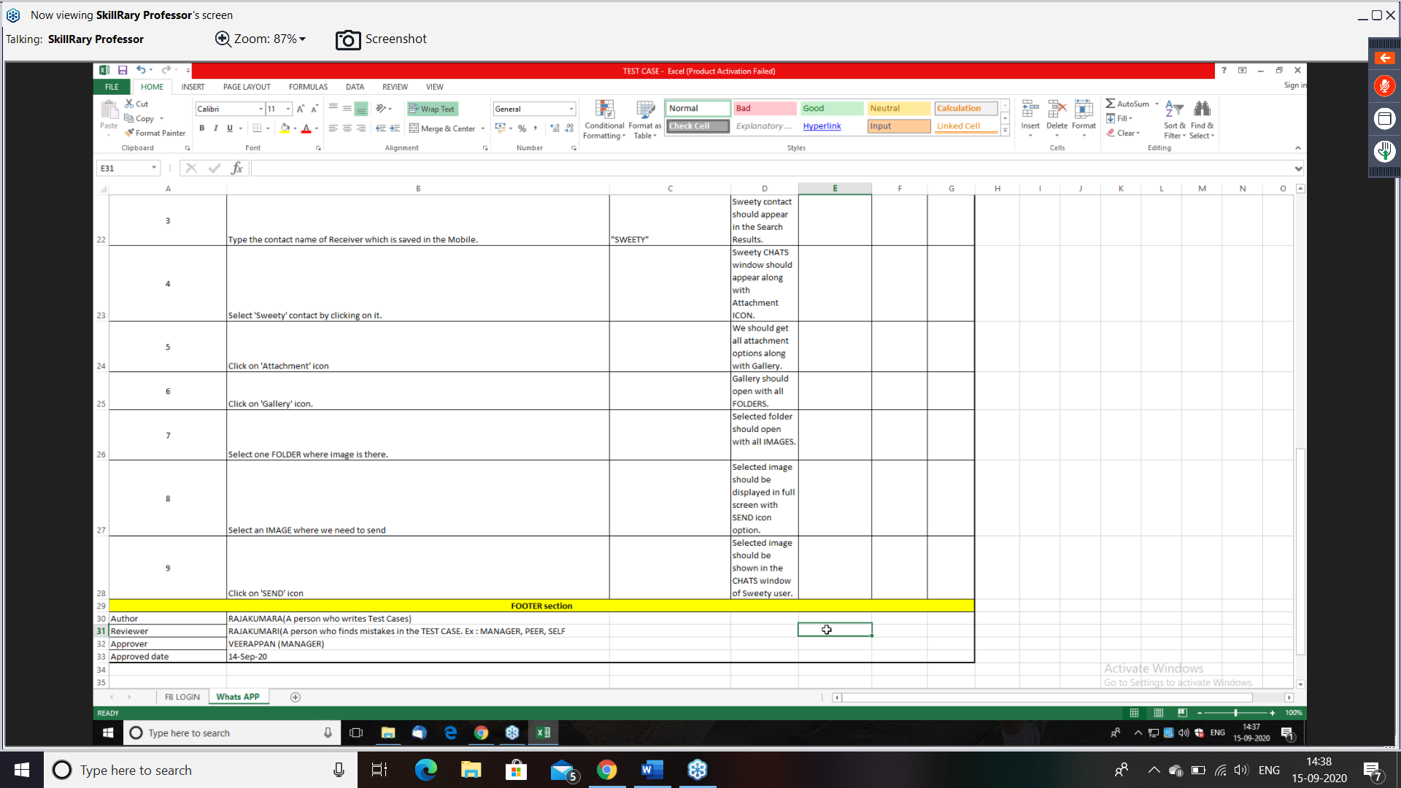

Requirement is: one person should send a photo to another person in whatapp.

Verify by sending image from one person to another person and check in whatapp.

For above requirement below is test case.

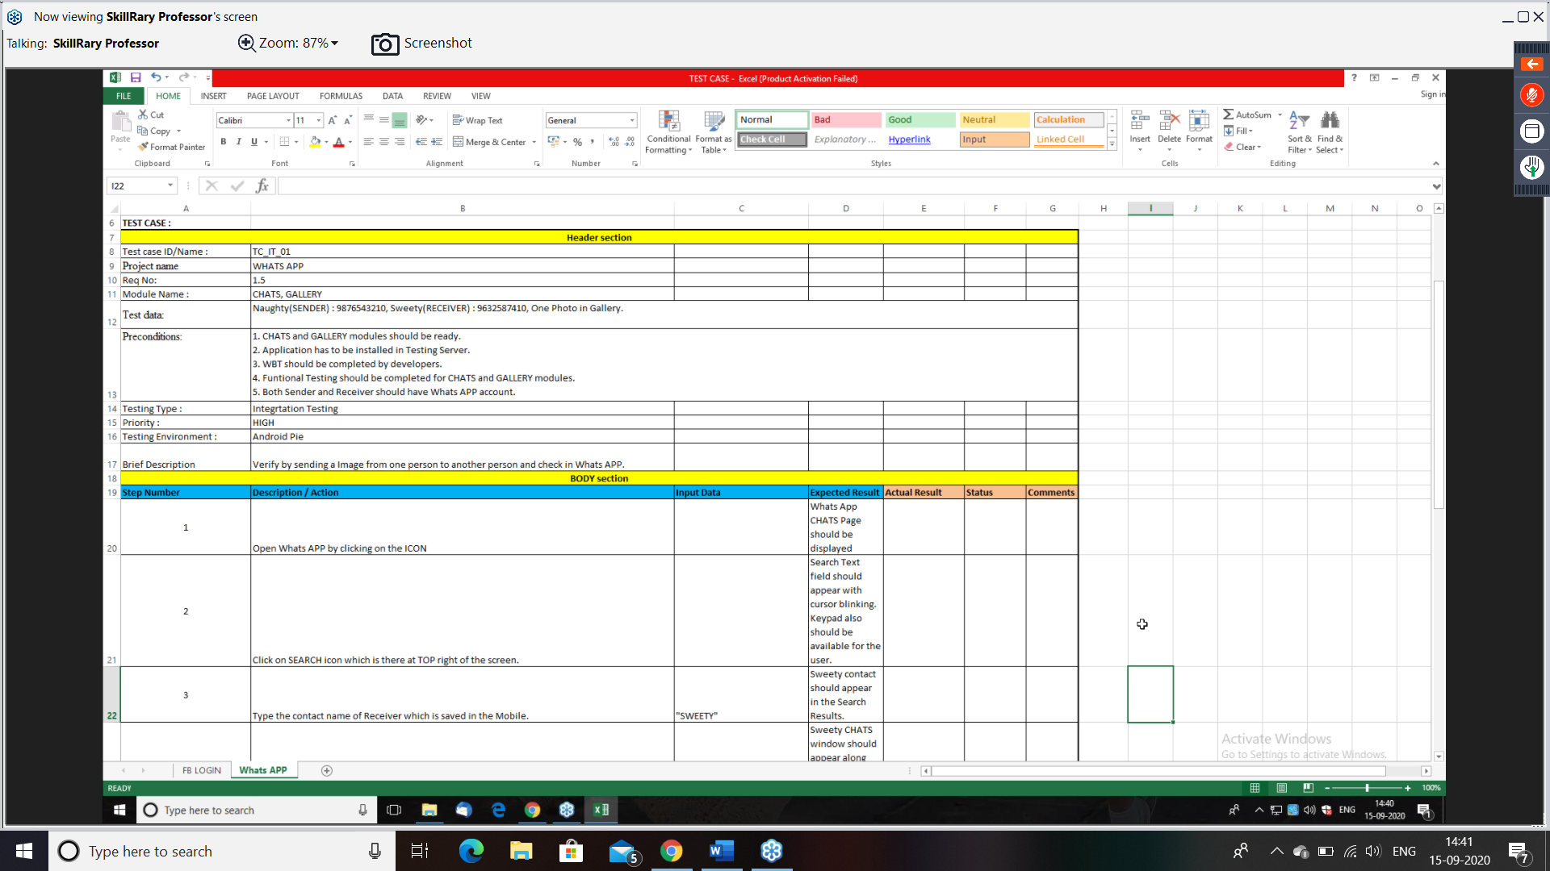

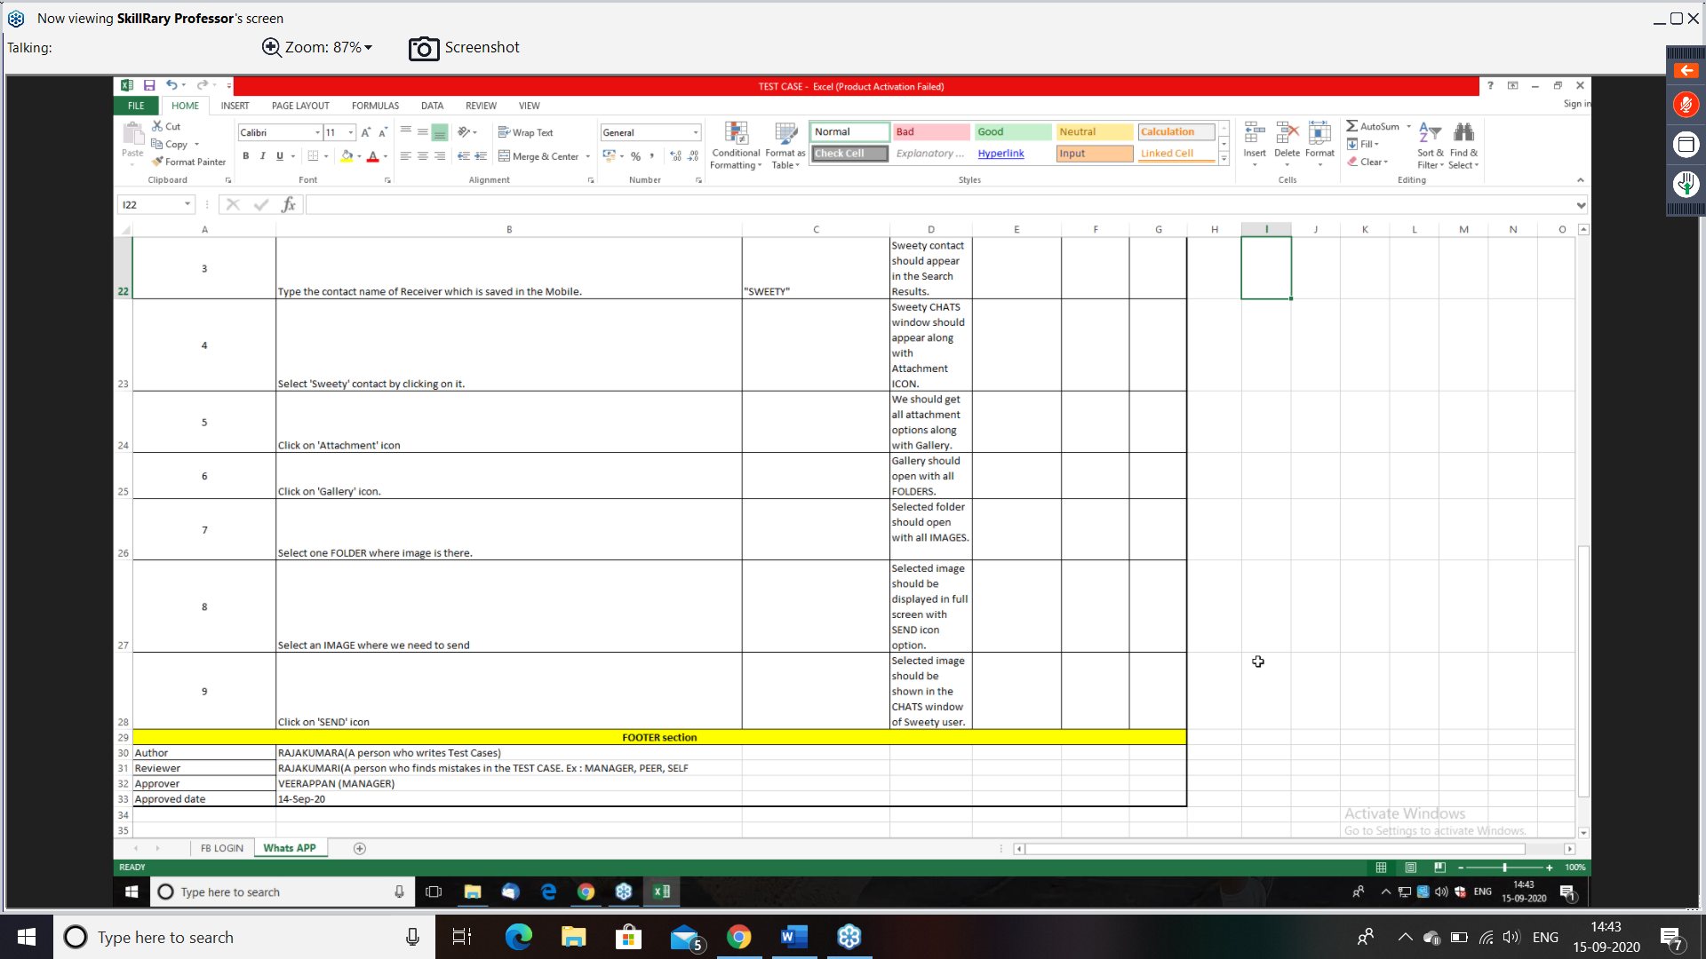

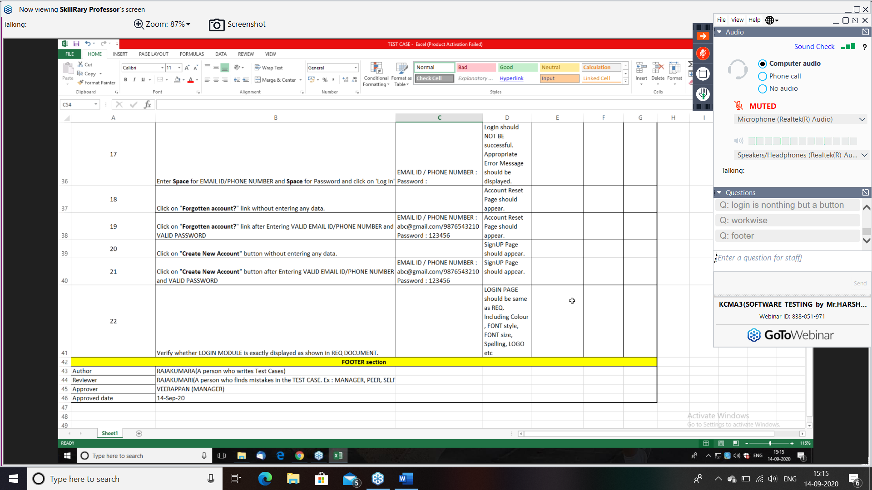

Write test case for below requirement. I need to send an email to another person and that should be there in send items.

(in Gmail application)

Example for system test case.

REQ: user should be able to send a message and check it whether it is sent or not and should be able to logout.

(Gmail application)

Scenario:

Verify whether we are able to send a message from compose and that appears in sent items.

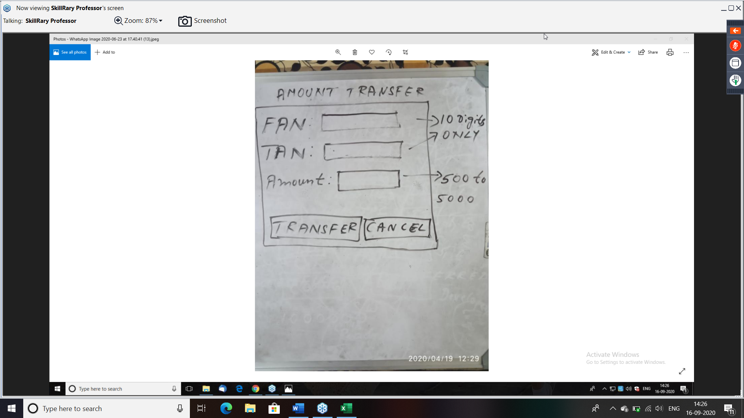

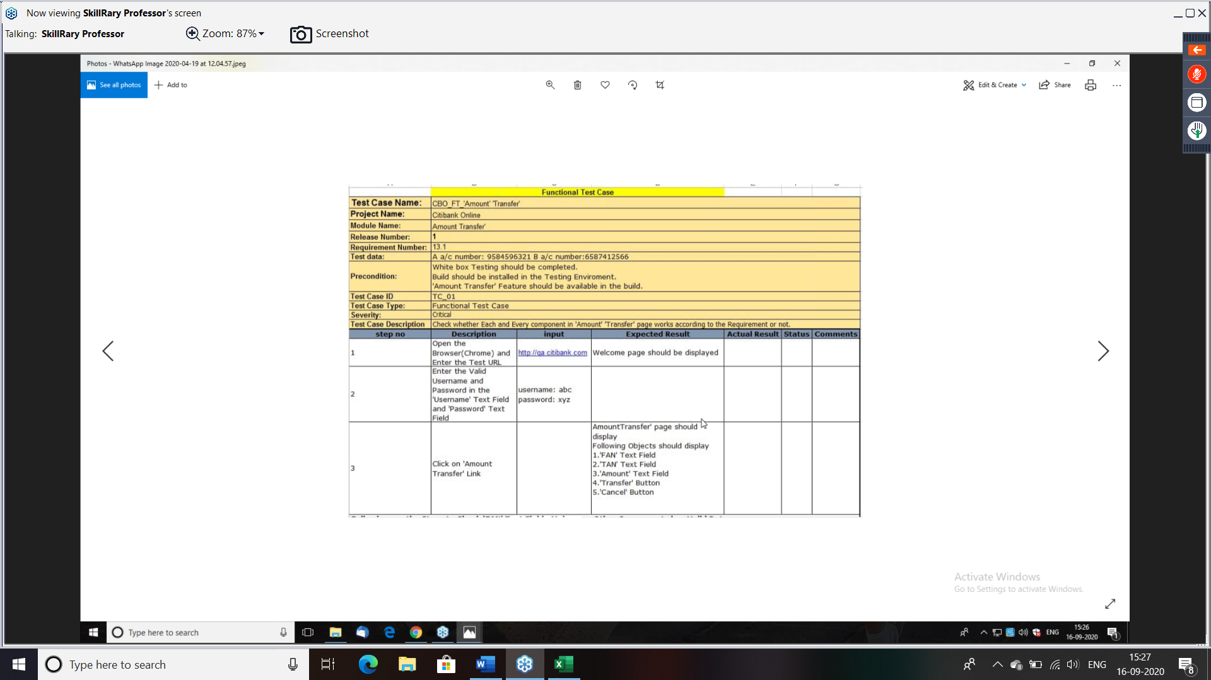

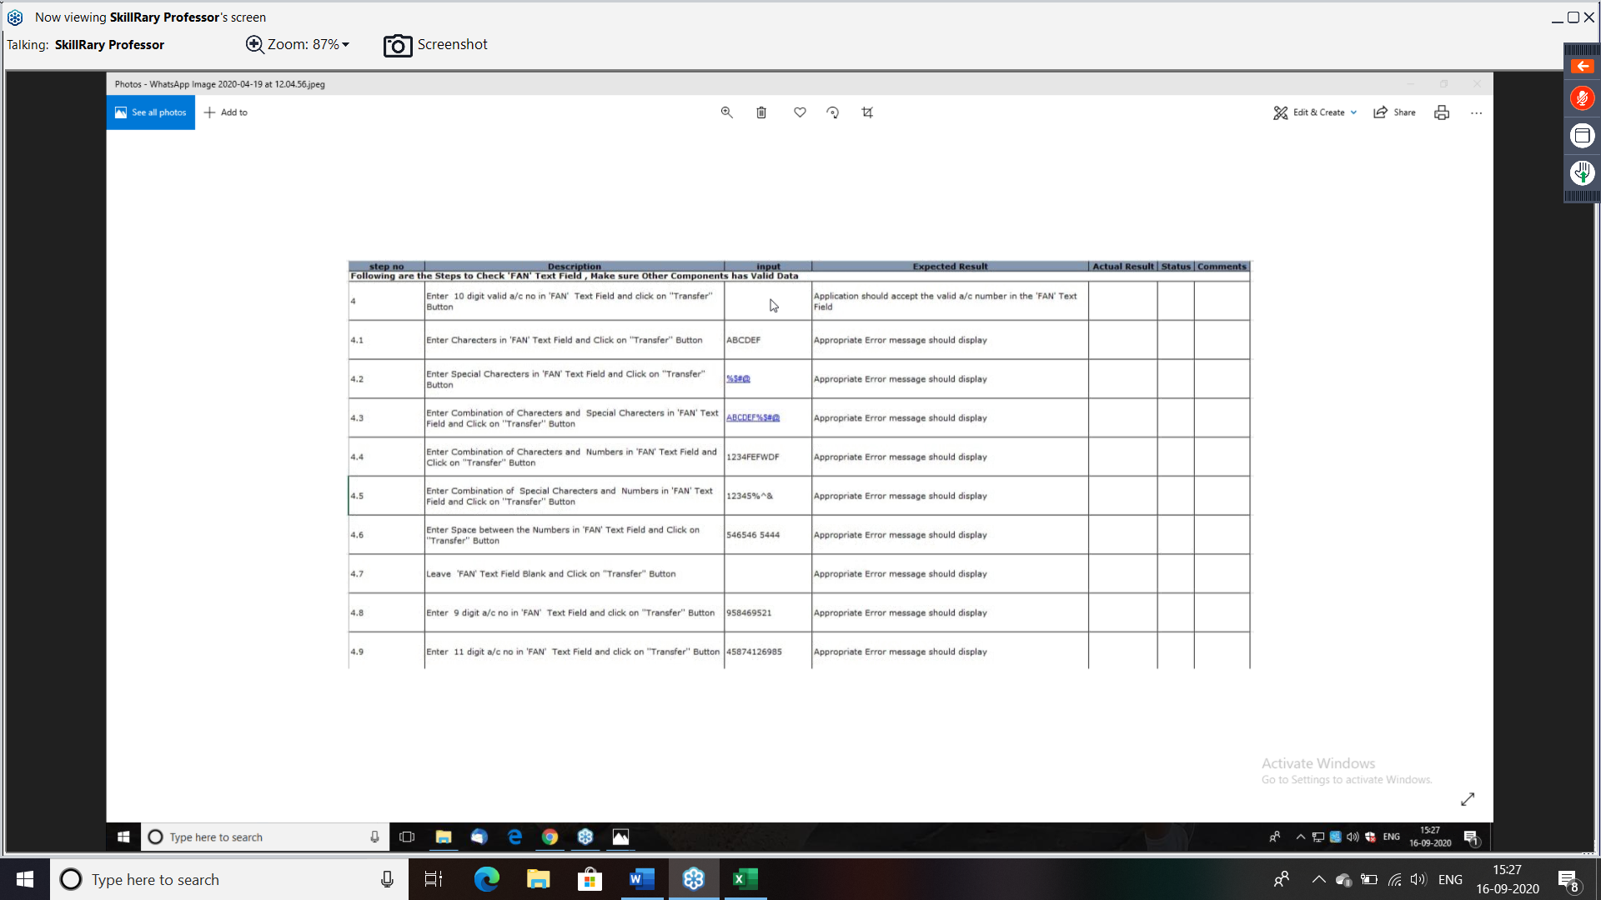

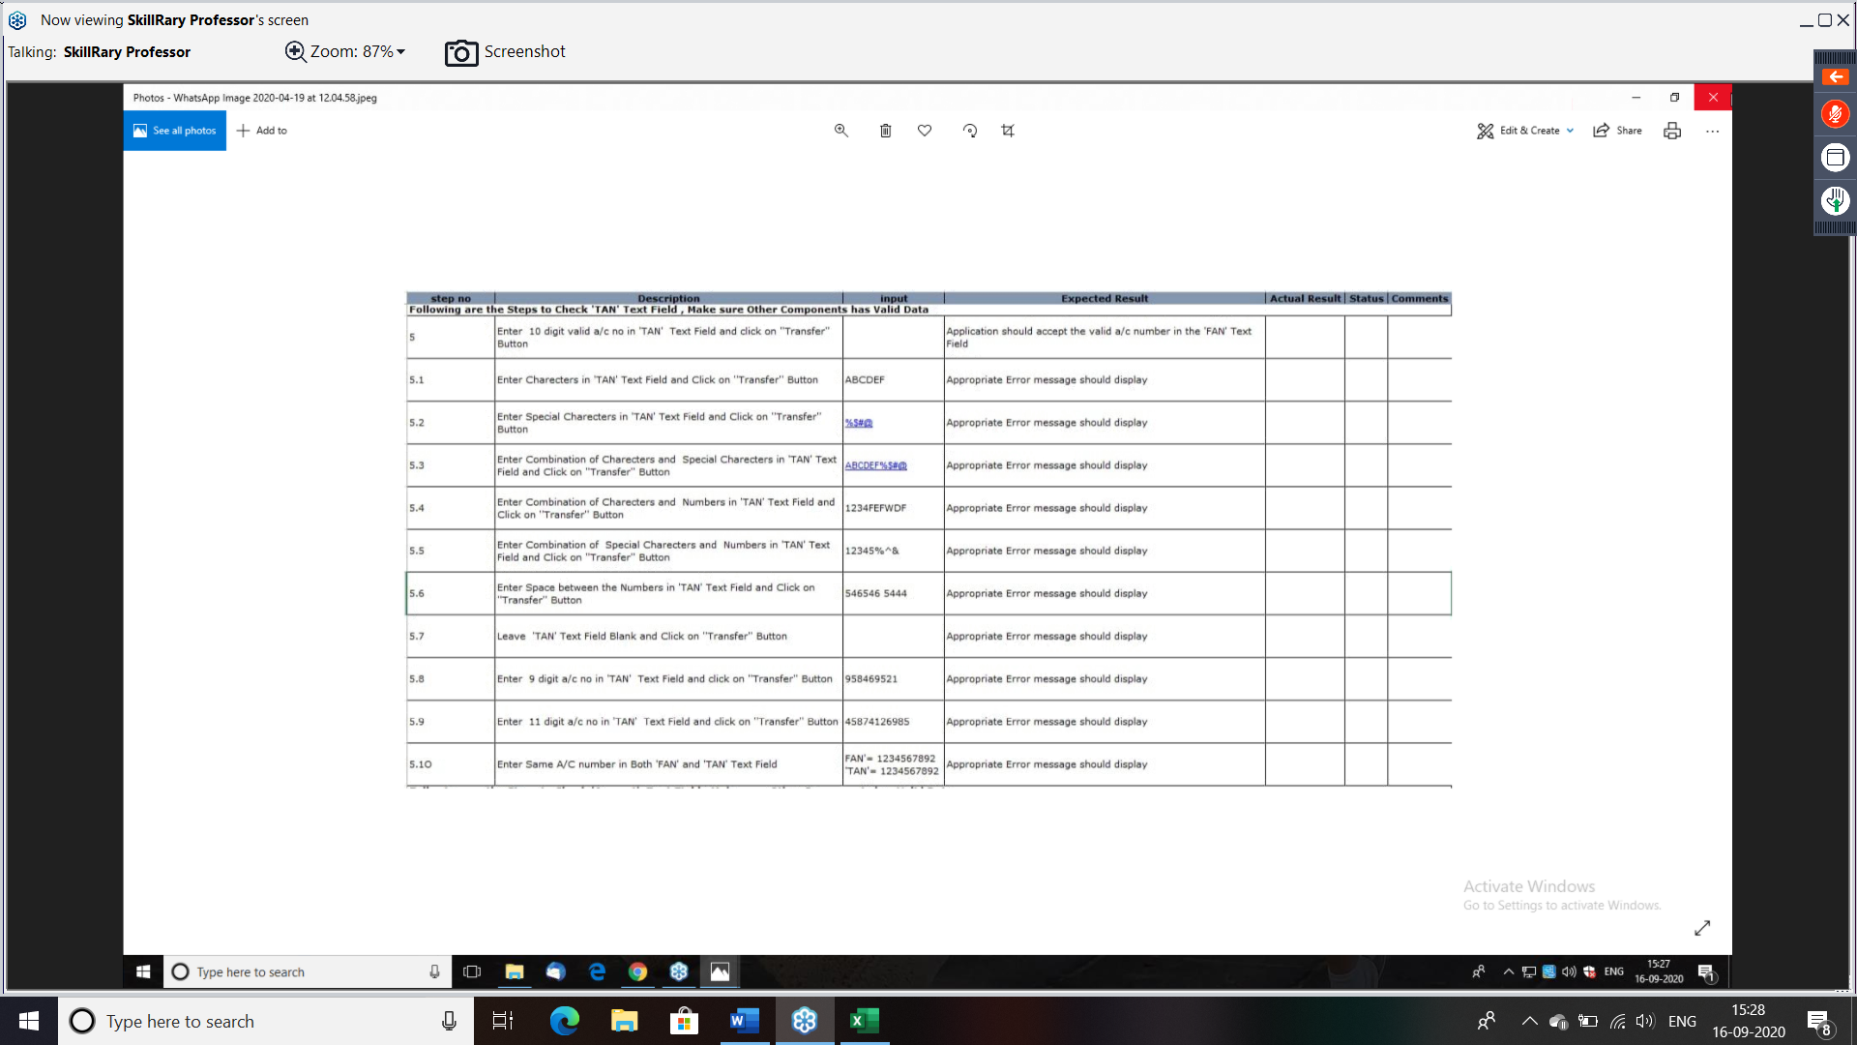

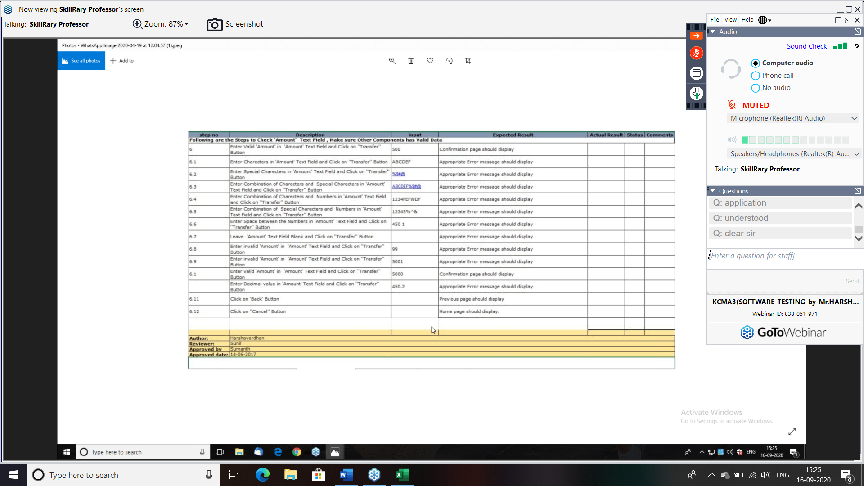

During interview, if they ask scenario or test case in written test, write scenarios max first and mention as “this scenario will be converted in to test case using template”.

To write test case template we don’t need any requirement.

To write test case and scenario we need requirement.

Why do we write test cases?

It is document, which acts like prof that we have testes everything.

It is written to depend on the process rather than a person.

It is document where all the team members including management and customer will ask for.

It is document which can reusable any number of times to execute.

It a document which is input for automation testing.

DRAWBACK OF MANUAL TESTING

It is time-consuming process.

It is a repetitive in nature (Because of REGRESSION TESTING)

Turnaround time is more in manual testing, so we go for automation testing.

Need more man power.

RETESTING AND REGRESSION TESTING:

Retesting:

Testing the defect fixed which is done on an application is called retesting.

or

Testing only defect fixed part is retesting.

Regression testing:

Testing the impact area of an application after defect fix or changes done for an application is called regression test.

Testing the impacted areas of an application:

* After the defect fixed.
* After changes done in application.

Changes can be adding, modifying and deleting a feature

Q. Why regression testing necessary?

Ans: Whenever a defect is fixed or new feature is added or modified, the existing feature can be affected. to ensure the existing feature are still working fine after these changes we need regression test.

This very important testing and it is repetitive testing.

Since, it is repetitive testing, it takes much time in manual testing, so it is better to go for automation testing.

Example:

If you found defect in your camera while you are testing your mobile phone. You have reported the defect and developer fix it and return it.

Now, you will first check your camera, if it’s working fine is called as retesting

Whereas when you check all the feature that was affected like (face unlock, video, scanner, video call, zoom etc). This is called as regression testing.

Q. whenever I am sending an email to 5 people, it sent only to 3 people.

What is retesting and regression testing here?

Ans: retesting- send an email for 5 people.

Regression: send a email to only 1 person.

Send an email to 6 people

Send an email to 5 other people.

Send an email for 5 people and also for some in CC

Send an email to our self.

Send an email with attachment for same 5 people.

Tools used in industries

Functional testing tools.

1. Selenium (can be used with core java, python, Perl..)
2. QTP/ UFT (quick test professional, unified functional test) can be used with VBS (visual basic scripting, java script)

Selenium is free and is an open source

Thought works is a company that came up with the selenium tool.

QTP/UFT id paid and licensed is with HP

(Hewlett Packard). Before it was with Mercury.

QTP is older version, UFT is latest version.

3. Win runner

4. silk test

5. test partner

Performance testing tools

Testing an application by applying load and check response time.

Load runner

J meter

QA load\Silk performer

Neo load

Load runner is a licensed tool. It is with HP.

TEST MANAGEMENET TOOLS

1. QC/ALM (quality centre / application life cycle management)

It is a licensed tool. It is with HP. it is PAID TOOL

1. JIRA. (best tool for AGILE model)
2. OTM (oracle Test Manager)
3. TEST link

Using the above tool, we can manage the testing actives like below

Requirement- (edit, add, delete)

Test plan- (write test cases)

Test lab- (execute test cases)

Defect- (repose defect or track defect)

What are the test management activities?

1. Going through the req given by the customer and adding to the test management tool.
2. Write test cases by identifying scenarios.
3. Execute test cases.
4. Find defect, report defect and track.

Defect or Bug Tracking tools

1. Bugzilla: it is an open source and free.
2. QC/ALM (quality centre / application life cycle management)

It is a licensed tool. It is with HP.

1. JIRA (partially free)

In Bugzilla we cannot add the requirement, write test cases and execute test cases.

We can only report the defect and track the defect.

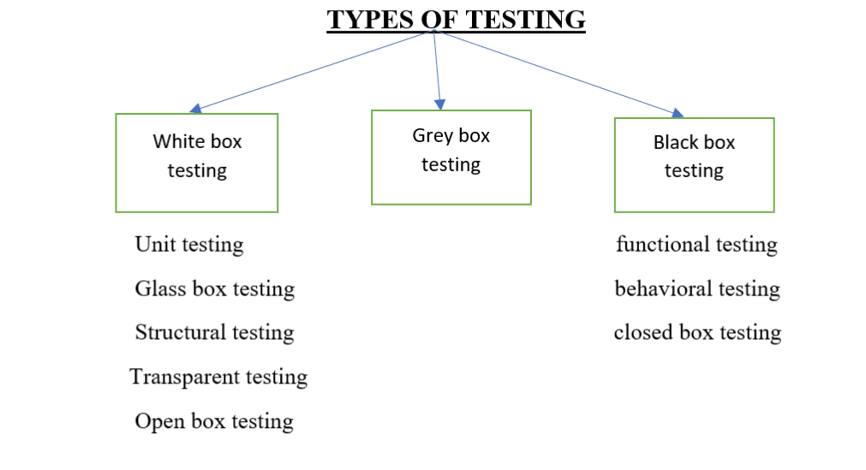

White Box Testing:

Testing the source code or internal structural of an application is called white box testing.

It is usually done by developer.

When situation demands even Test Engineer can do this if we know coding.

Black Box testing: Testing the user interface (UI) or graphical user interface (GUI) of an application is known as Black box testing.

Here we don’t worry about internal structure of an application.

It is done by test engineer.

Grey Box Testing:

Testing the source code and user interface of an application parallel is called grey box testing.

It is done a person who is aware of both testing and source code of an application. Means he can be a developer or test engineer or he can SDET (software development Engineer in TEST)

White box testing/ unit testing tools

Junit: when the source code is written in java to test, we use junit.

Nunit: when the source code is written in .net to test that we use nunit.

Selenium is a tool to test the black box testing. It cannot be used for WBT.

WBT

manually (check each and every code (LOC) manually without using a tool

ex. checks the syntax and logics etc)

automation (1. write a program to develop

2. write program to test developed program

3. Run the test program in to tool.)

BBT

Manually (check each and very functionality without using a tool on UI.)

automation (Write a program (TEST SCRIPT) (using selenium qtp)

to use selenium core java is used for qtp vb is used.

2. Run the test program in the tool.)

|  |  |
| --- | --- |
| White box testing | Black box testing |
| It is testing source code of an application | It is testing UI of an application. |
| It is first type of testing | After white box testing, we do black box testing |
| To do this testing we should have knowledge of programming | No need of programming knowledge |
| We need internal structure knowledge of an application | to this we need not have knowledge |
| We can use tool like junit nunit etc | We can use tool like selenium, QTP UFT etc |
| It is usually done by developers | It is done by test engineers |

Black box testing types:

All the testing which we perform on the UI of an application on GUI of an application comes under black box testing.

Function/ field level testing/ component Testing:

Testing each and every component individually with respect to requirement thoroughly is called functional testing.

Example: I have done functional testing for Facebook login page and below is observation:

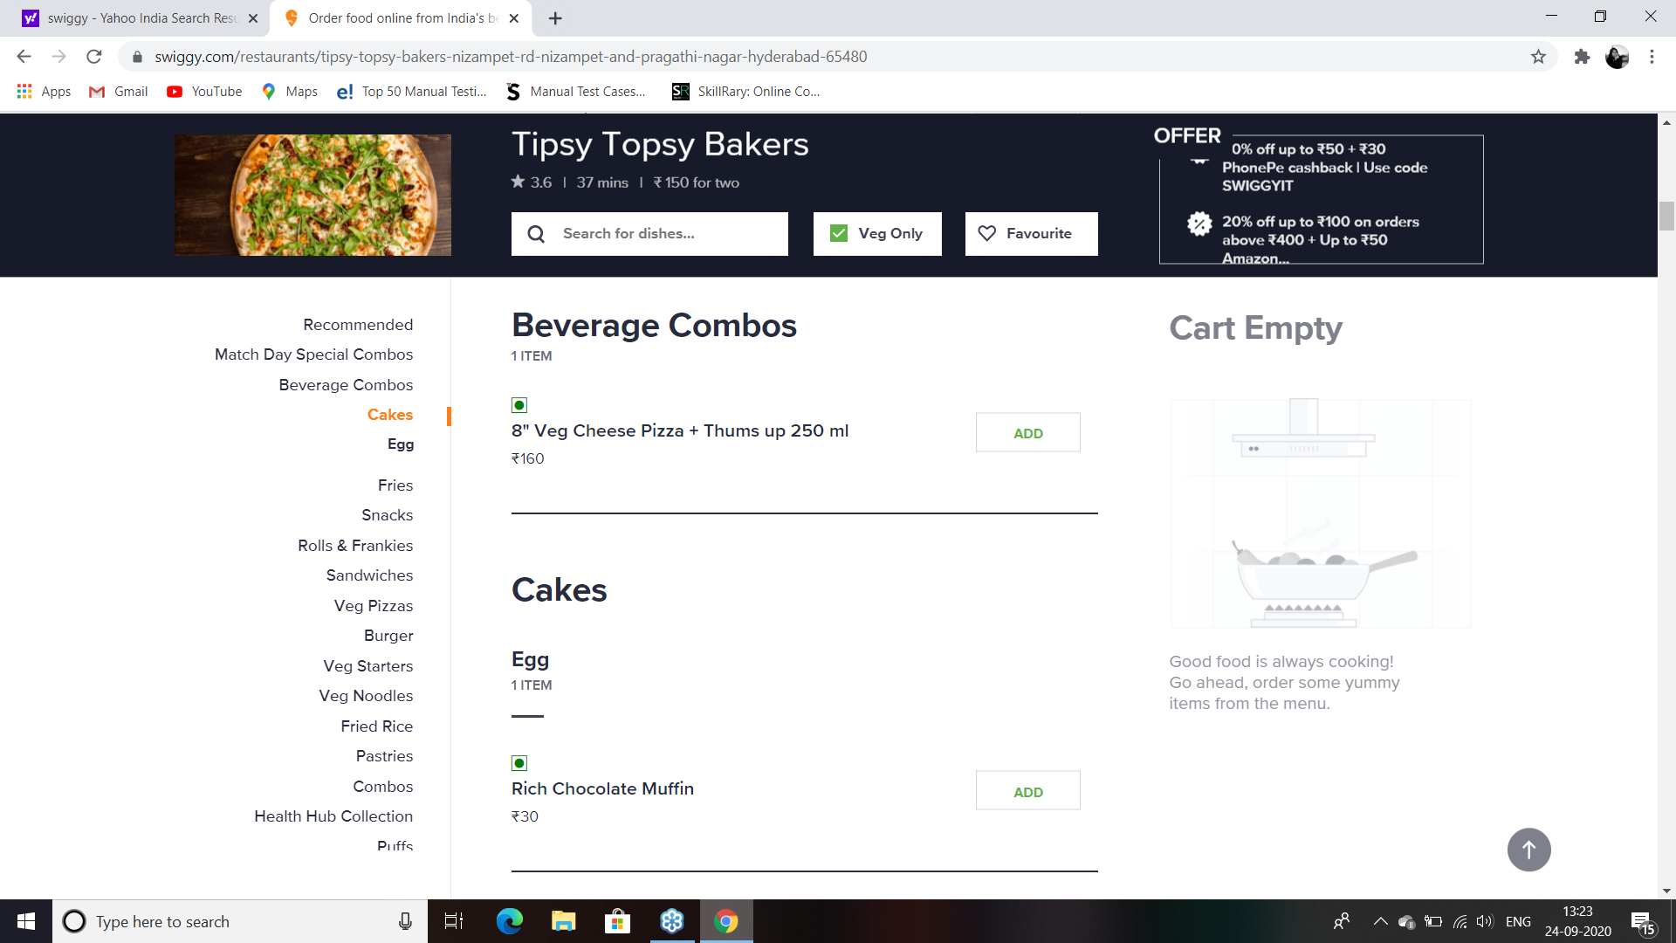

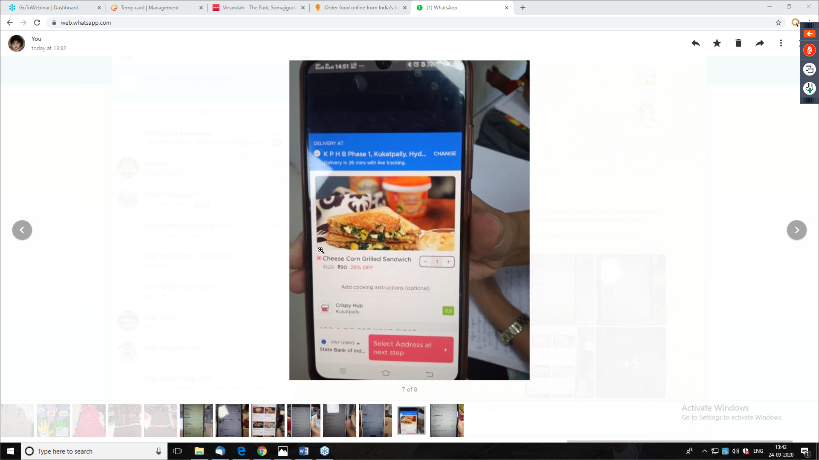

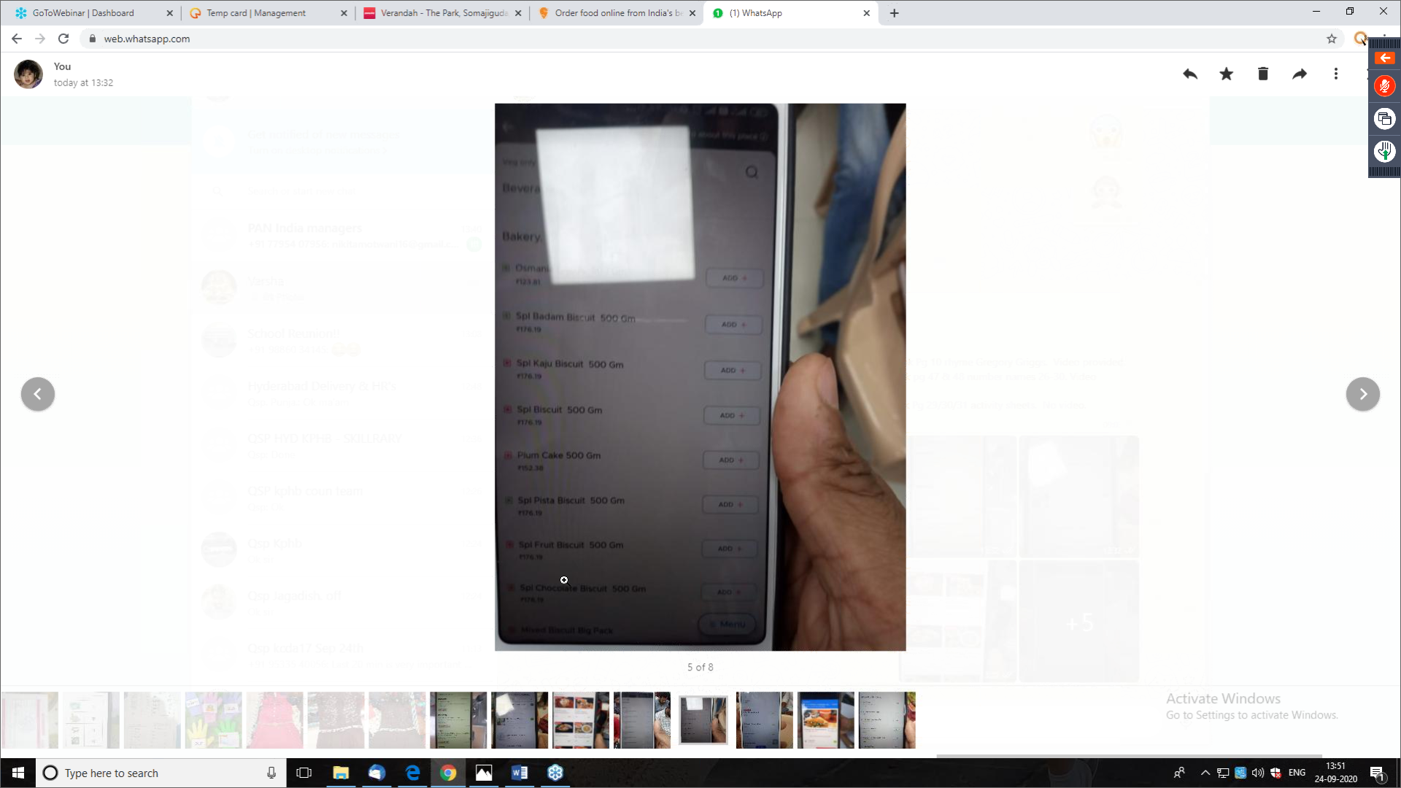

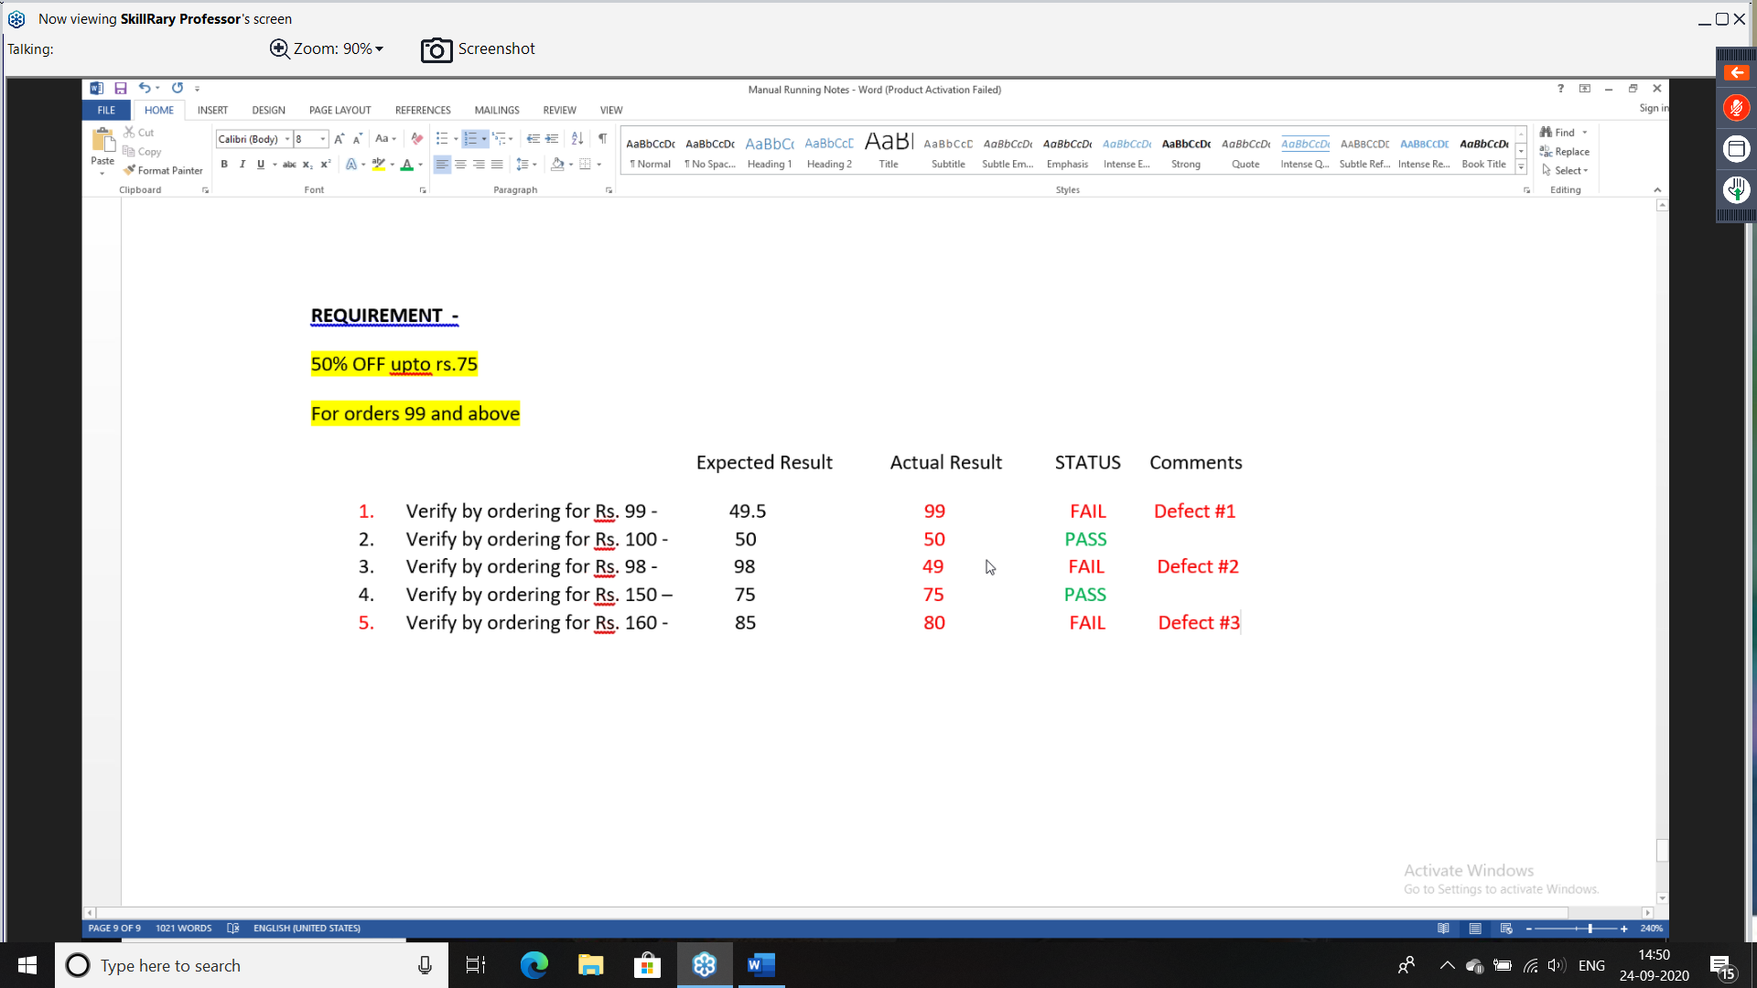

Functional testing will be done on each and every component like, test fields, radio buttons, drop downs, checkboxes, links, buttons etc

Integration testing: Testing the data flow between two or more dependent modules is called integration testing.

- To do integration testing we need at least two modules.

- here we only Concentra on the data flow

System testing:

Testing the application end to end like real user is called system testing.

Types of Integration testing:

In integration testing we have different types

1. Incremental integration testing
2. Top down
3. Bottom up
4. Non incremental testing or Big bang testing

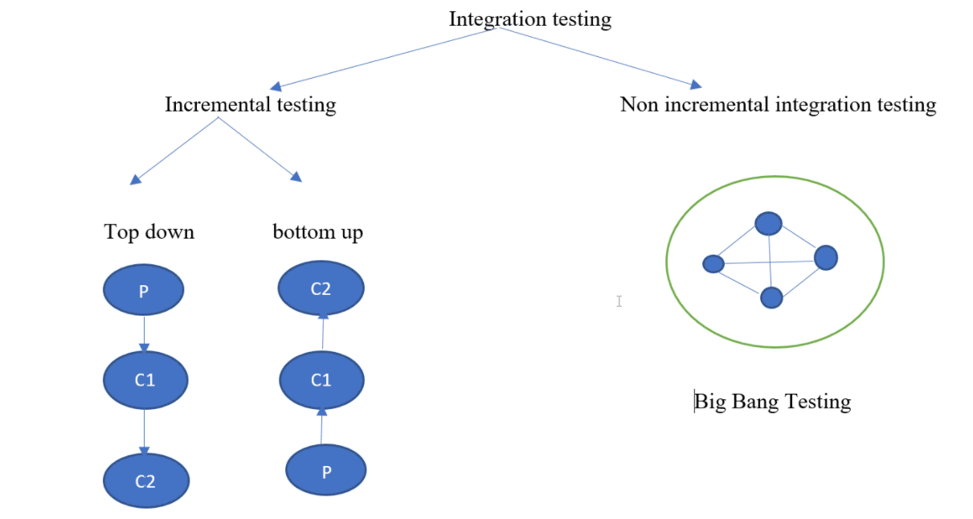

Incremental Integration testing:

Whenever parent module is there child module is added and we do integration testing

OR

whenever child module is there parent module is added and we performing the integration between there module is called integration testing.

Example: ATM, ola.

Hybrid/ sandwich integration

In the sandwich/hybrid strategy is a combination of top Down and bottom up approaches. Here, top modules are tested with --- the same time lower module are integrated with top module and tested. This strategy makes use of stubs as well as drives.

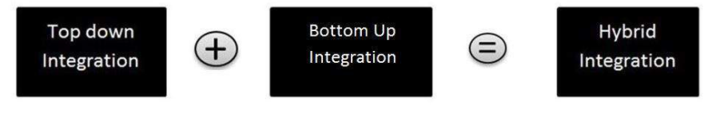

Non incremental integration testing:

Whenever we cannot find which is child and which is parent even then we find the integration testing between them is called non incremental integration testing.

Example: WhatsApp, Facebook, Gmail

STUB- acts like a child module when child module is not present

Drivers: acts like a parent module when parent module is not present.

What are STUBS and DRIVERS?

Or one module is ready and another module is not ready, how can we do integration testing?

Stubs:

It is dummy module w0hich acts like child module.

Whenever there is no child module available, stubs will receive the data and acknowledges the data.

Drives:

It is dummy module which acts like parent module.

Drives will send or trigger data and send data to child module.

Subs and drivers are mainly used in critical project related to space, medical submarines, defence etc

SYSTEM TESTING

Testing the application end to end just like a real user is called system testing. It is done on testing server, which is similar to production server.

System testing scenarios

Ex Sing up🡪 login 🡪 compose 🡪 sent Items🡪 logout

Ex: Login 🡪 inbox🡪read Email🡪 reply🡪 sent Items🡪 logout

Software Testing life cycle:

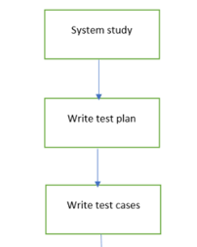

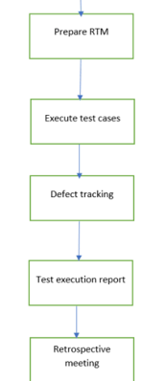

System Study:

It is going thought the requirement given by the customer and understand how the system works.

Write test plan:

It is document which is prepared for FUTURE testing actives. It is done by the test lead or test manager. Because the plan will be done by experienced people.

Write test case: It is step by step procedure to perform the testing on the application. it is done by test engineer. Once we go through the requirements, we identify the scenarios and then converts into test cases. To write the test cases, we need requirement and test case template or tool (QC/ALM, JIRA)

Prepare RTM: Requirement tractability matrix, itis a document which is prepared to check whether every requirement has at least one test case or not

To prepare RTM, we need both requirement and test cases.

Execute test cases:

Once the requirement is given to the test engineer, he writes test cases for the application. After the developer gives the developed application, then the testcases are executed and it is compared with expected result and actual result. If the expected and actual result are same the status is PASS, if the expected and actual results are not same status will be FAIL. this is called execute test cases.

So, to executed test cases we need test cases and software application. this is where exactly the software is been tested. This is the most important phase of software life cycle.

Defect tracking:

while executing the test cases, we may come across the defects these defects are raised/ logged/ reported to the developer Once we raise, we should also check what is happened to that defect. This is called defect tracking.

It is done by using tool called Bugzilla, QC/ALM, JIRA

Test execution report:

Once we executed test cases, we should prepare one document called test execution report. This document tells about how many test cases are PASS and how many test cases are FAIL.

Till here customer involvement will be there. According to the customer, this is the end of the project.

Retrospective Meeting/ Post-mortem meeting:

In the meeting, all the team members will gather together like, PM, TL, DL, DEV, BA, TM and they discuss about the good and improvements needed once the project is done. This will be very useful for next release or next project.

Note:

*STLC is a part of SDLC*

*STLC it is procedure to test a software application*

*it contains different phases*

*system study (REQ): customer gives (testing team will go through)-REQ*

*prepare test plan: Test lead/Test Manager -REQ*

*Write test cases: Test engineer -REQ*

*prepare RTM: Test Engineers -REQ& Test cases*

*Execute Test cases: Test Engineer -APP & TC*

*Defect Tracking: Test Engineer -Report, Track*

*Test Execution Report: Test lead/ Test Engineer*

When we are executing the test cases if the expected result and actual result are not same, we come across the defect. Then the defect is raised to the developer, the status will be NEW/OPEN. That defect will be assigned to the concerned developer or development lead (if we don’t know the correct developer), then the status changed ASSIGNED.

Then developer will reproduce the defect and if it is reproduceable, he will accept it. Then he starts fixing the defect in the development server and it has to be installed to testing server once he fixed it. Then he should change the status to FIXED.

The test engineer starts retesting the defect fixed in the testing server. If the defect is properly fixed, then status will be Closed. If the defect is not properly fixed, then again, the defect is REOPENED to the developer

This whole process is called Defect Life Cycle/Bug Life Cycle/ Status of Defects.

Note: The status of this defect will be used in defect report.

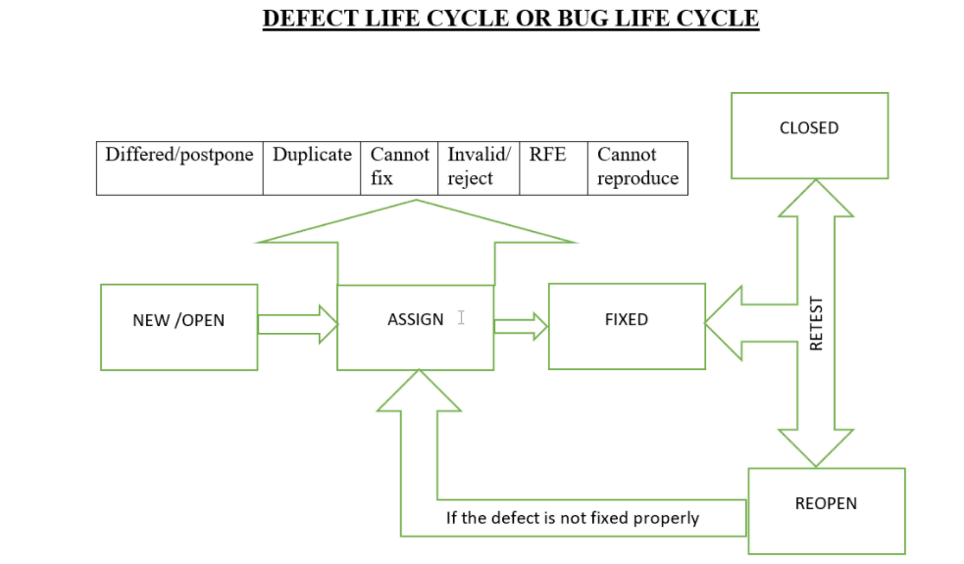

What is duplicate status?

Whenever the test engineer finds the defect and he raise it. If another test engineer or same test engineer find the same defect and raise it unknowingly / mistakenly, then the status of that second defect is changed to duplicated defect.

To avoid this (Duplicate) when test engineer finds the defect, check whether same defect is raised in the repository (ex: BUGZILLA, qc/alc/jira)

Invalid:

Whenever developer not ready accept defect due to any reason he will change status to invalid.

Reasons for invalid:

If the engineer misunderstand requirement

New/open🡪 assign🡪 invalid🡪 closed

If developer misunderstand the requirement ``1

New/open 🡪 assign 🡪 invalid🡪 reopen🡪 fixed 🡪 closed

Deferred or Postpone:

Whenever test engineer raises the defect, the developer accepts the defect but he will not fix the defect immediately. He will fix it later, then the status of those defect will be done as deferred / postpone.

Whenever there is a major defect and minor defect. Developer have less time to fix the major defect, in this case the developer will fix the major defect and for minor defect he will make status as deferred or postpone.

Can’t be reproduce:

When the test engineer finds the defect but developer won’t able to reproduce it, developer will change the status as cannot be reproduce.

Ex: mobile hang etc

Reasons for can’t be reproduce

1. Installation problem
2. Improper defect report
3. Inconsistent bug

Can’t be fixed:

Whenever the developer is unable fix the defect that is raised by the test engineer, then he changes the status as “can’t be fixed”. And it is valid defect but he can’t fix the defect.

Ex: Whenever Technology does not support to fix thar defect, then developer will change the status to “can’t be fixed”

Request for enhancement (RFE)

Whenever the test engineer raises the defect which is not given in the requirement so the developer will take it as suggestion. In this case he will change the status as RFE.

Example: when we done have requirement mentioned to have select all but you feel it should be present. Then developer will make it RFE

SEVERITY:

Severity will tell how much that defect is affecting the customer business.

Types Of severity

1. Blocker/ shows topper
2. Critical
3. Major
4. Minor
5. Trivial (this defect is negligible)

Whenever we try to transfer money, if transfer button is not functioning this can be blocker severity.

Critical severity is whenever we transfer money, transfer happen but transaction history is not displaying.

Whenever transfer money transfer is happening but the message which is displayed is not sensible, this can be Major

Ex: instead of successfully transferred, we are getting beautifully transferred.

If there is a minor spelling mistake, even then we can understand the sentence, those comes under minor severity

Ex: instead of successfully, we are getting sucesfully

If requirement says we need full stop at the end of the statement and it not added this can be stated as Trivial defect.

PRIORITY:

Priority says which defect has to be fixed first by the developer.

For every defect we have to set priority

Different types of priority

1. High
2. 2.Medium
3. 3. Low

Or

1.urgent

2.high

3.medium

4. low

Or

1. P1
2. P2
3. P3

Who will set severity and priority?

Test engineer will set severity and priority.

Developer or managers can discuss about this if they want to change it, they have to provide proper justification.

Priority is very much important for the developer to decide which defect has to be fixed first

If priority is not there, developer may fix the easy defects and they leave all the important defects.

As a project point of view, the important part of defects has to be fix earlier. To manager this thing, we have severity and priority for each and every defect.

Priority can change once other defects are fixed and closed.

Q. Give example for Minor severity and High Priority

Ex. 1 instead of GMAIL it is CMAIL

1. Instead of FACEBOOK, it is PHASEBOOK
2. LOGOS mismatch

Any defect which has High VISIBILITY and impacting the brand value, that comes under HIGH PRIORITY and MINOR SEVERITY

Q Give me example of CRITICAL severity and low priority

EX.

Flipkart- APP

Defect

For UMRELLA discount not shown- for all 3 browsers

3defects raised

Defect: 101 ( Discount is not displayed for Umbrella in Homepage in CHROME browser)

Status: New

Severity: Critical

Priority: Medium

Defect: 102 (Discount is not displayed for Umbrella in home page in FIREFOX browser)

Status: New

Severity: critical

Priority: HIGH

Defect: 103 (Discount is not displayed for Umbrella in home page in IE browser)

Status: new

Severity: critical

Priority: LOW

Note: depending on importance of browser according to customer requirement, we will decide which browser is HIGH priority and LOW priority.

Defect report:

-Defect Id: 001

-Build No: B02

-Test case number: Tc_FT_02

-Status: NEW

-Severity: Critical

- Priority: HIGH

-Test Environment: Chrome

-Module Name: LOGIN

-Reported by: RAMA(TE)

-Assignee/ Assign to: SHAM (dev)

-Brief description: Login is happening even if we enter invalid password

-Test Data:

valid Username: Saieswar143143@gmail.com

valid password: Saieswari

Invaild Username: Saieswar143143$gmail.com($is extra)

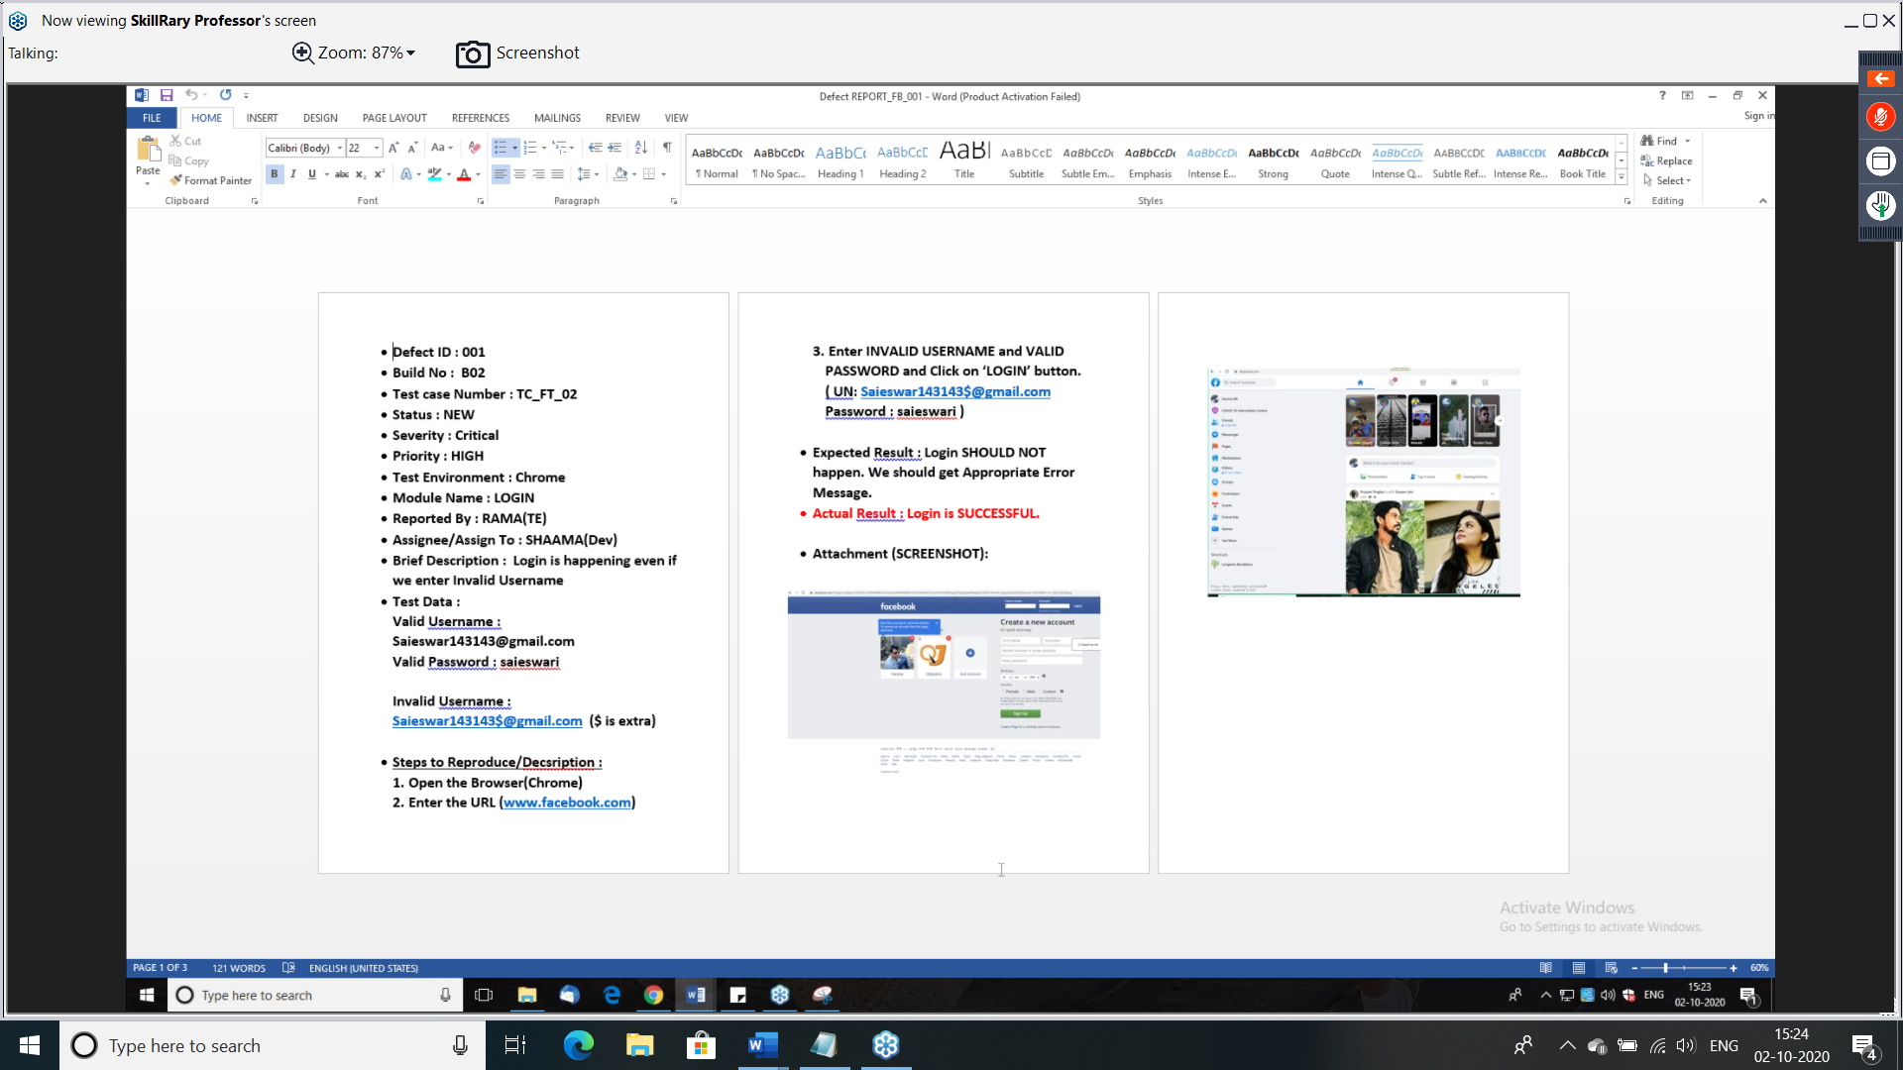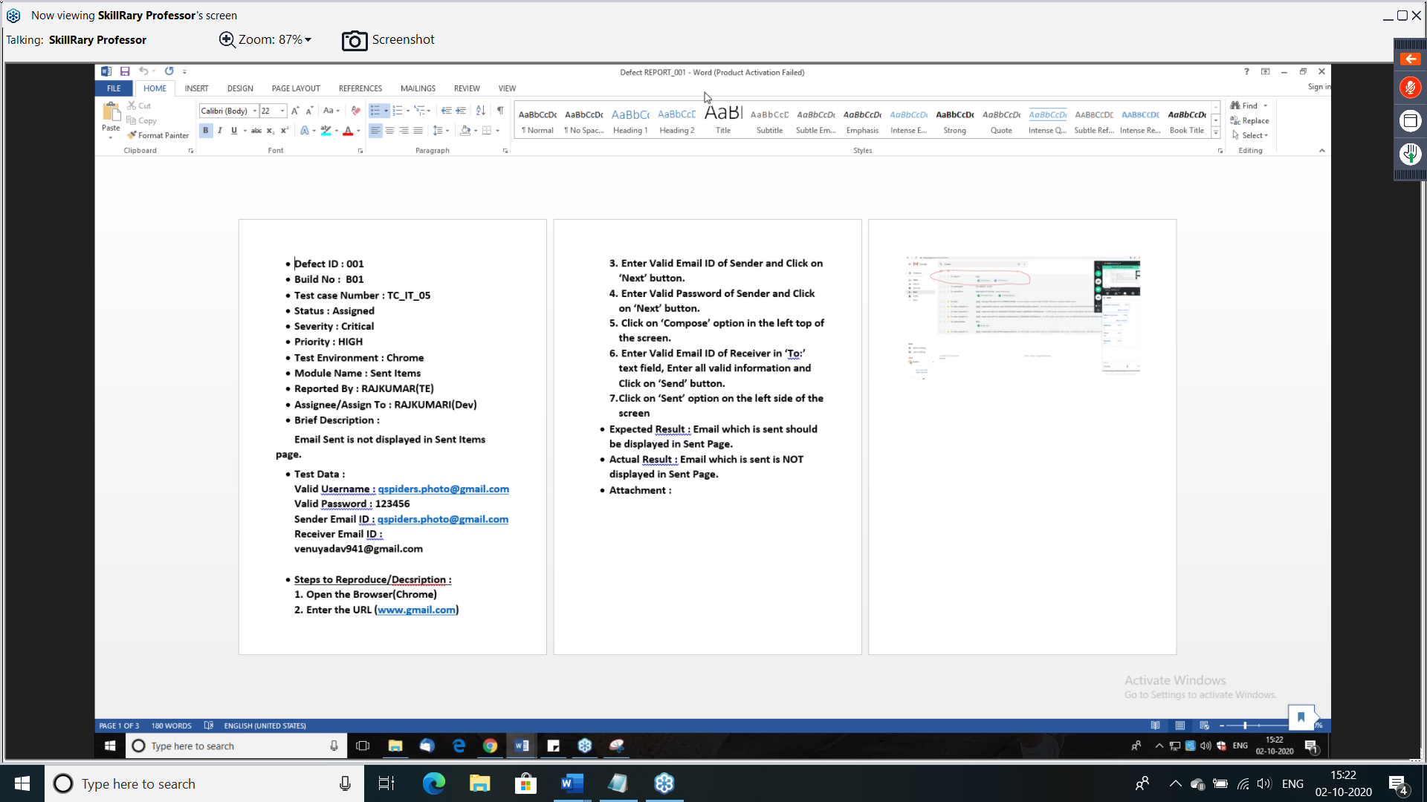

Assignment : in whatapp mdg is not sent

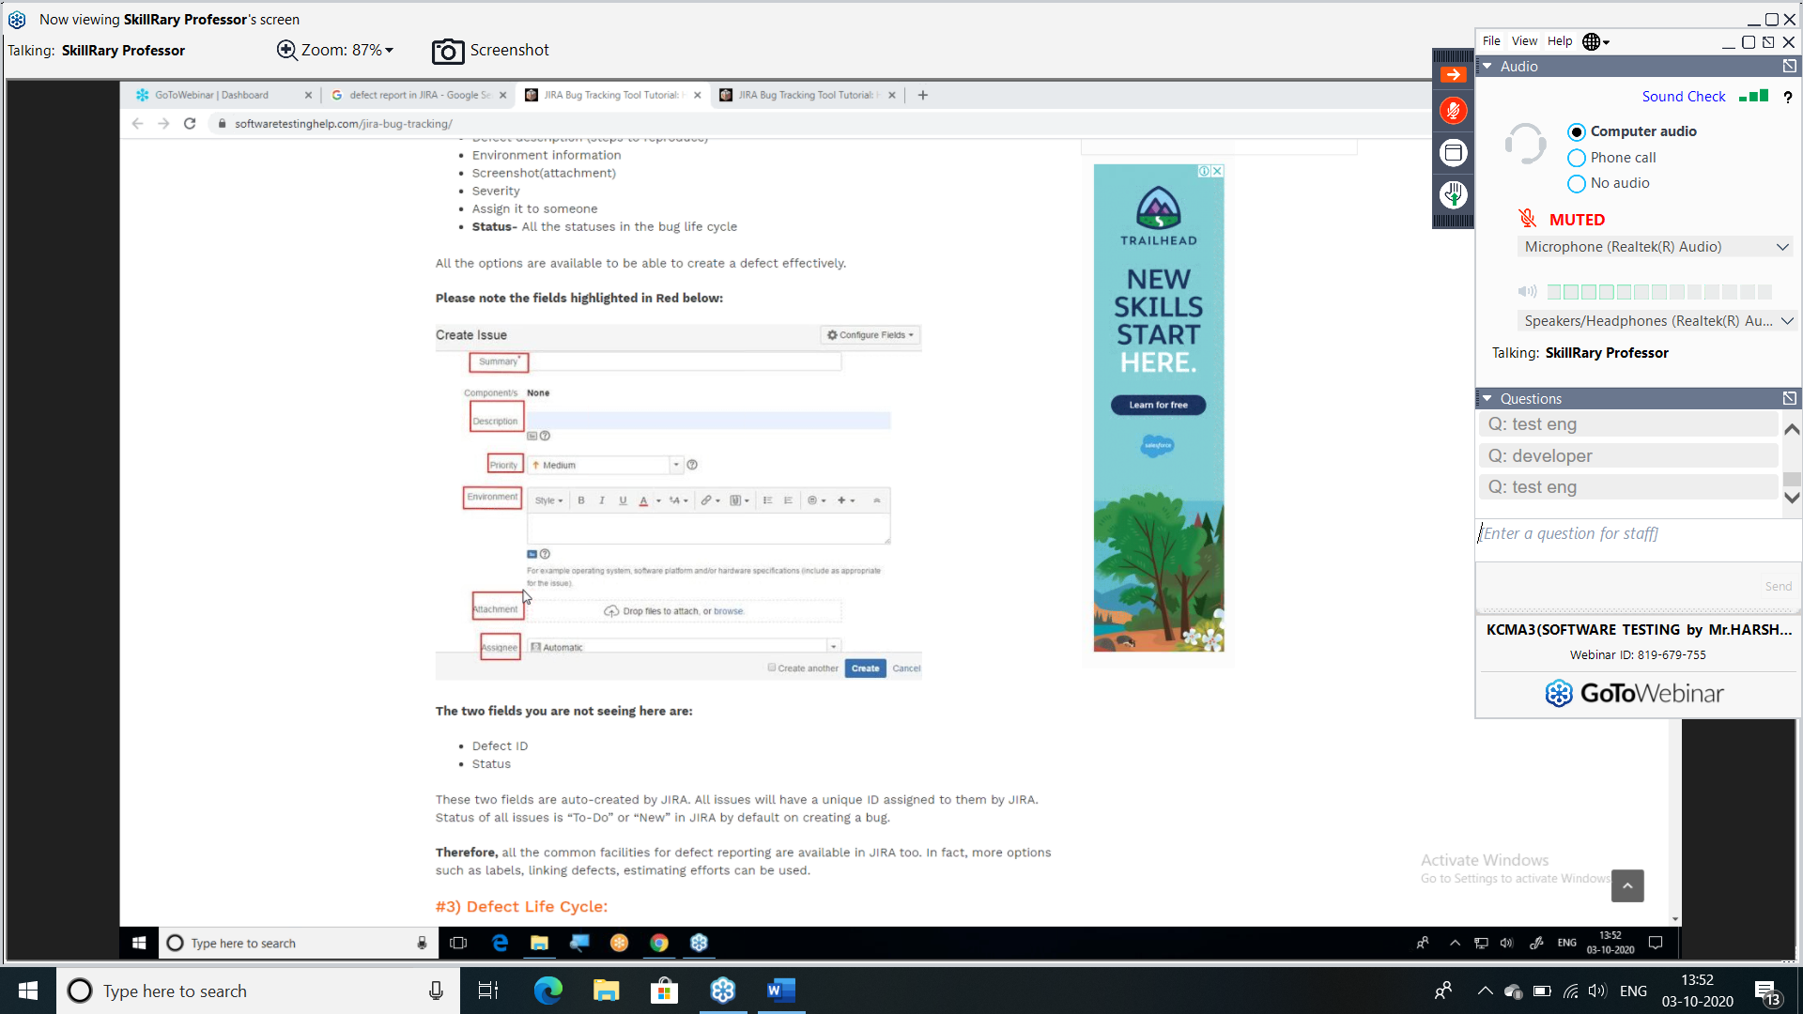

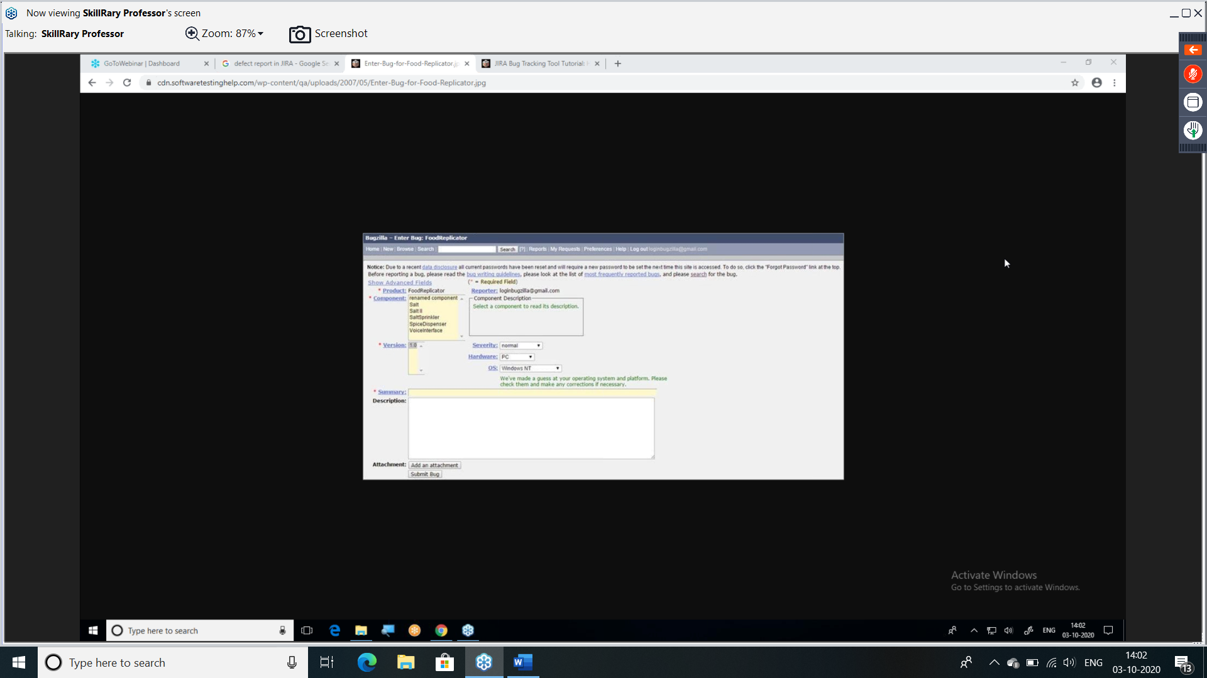

Note: we can report the defect in excel or word document or tools. Like QC/ALM, JIRA, BUGZILLA.

In QC/ALM, the term used is defect, in JIRA the term used is issue and in BUGZILL it is bug.

The attributes of defect report and the terminologies used can vary form tool to tool but the meaning remains same.

***for any application in the world, we do functional testing, integration testing and system testing.

* Whereas we also perform different types of other testing based on situation.

SMOK TESTING:

It is testing the basic features of an application before we do through testing like, functional, integration and system testing.

Why we do smoke testing?

Test engineer will get confidence on basic feature, that is working fine or not.

If we find the defect in the basic feature only, that create a good impact on the testing team.

If there are any blocker or critical defect found in the basic features, developer will get more time to fix the defect.

When we do smoke testing?

Once the build is given by the developer, we start doing smoke testing first.

For every build given by the developer we start with smoke first we assure basic feature are working fine.

When time is less for testing team to do the testing, we will do smoke testing and if the customer is fine, we will release to customer.

Difference b/w formal and informal smoke testing?

|  |  |
| --- | --- |
| Formal smoke testing | Informal smoke testing |
| It is document type (TEST CASES) | There is no Documentation |
| We have a proof | There is no proof |
| It has a procedure | There is not proper procedure |

Difference b/w smoke testing and sanity testing

|  |  |
| --- | --- |
| Smoke Testing | Sanity testing |
| It testing the basic feature only | It is testing the new features and bug fixes |
| It is shallow and wide testing | It is narrow and deep testing |
| Only positive testing is done | Both positive and negative testing are done |
| It is done on the unstable builds | It is done on the stable builds |
|  | It is subset of regression testing |

Real time project or how are the servers used or build process

Usually we have 3 servers like development server, testing/ QA server, production server. Customer gives the requirement then the developer start writing the source code for developing the application in the local system, this is source code will be saved in the repository (ex: github, vet, cvt). there white box testing will be done by developer. the source code will be complied and compressed, then we will be getting a file called BUILD. All this will be happened in development server.

The build has to be installed from development server to testing server. it will be done by the installation team or testing team or development team, depending upon project to project

Once build is installed to the testing server, testing team will perform different type of testing depending upon the content of the build ex for new feature FT, IT will be done for old feature regression testing for defect fixed retesting will be done.

While doing the testing, we find the defect that will be raised to the developers. Development team will reproduce the defect and they will fix it in the local system and it is saved in the repository again. same process will be repeated for every build, until we get the final stable build.

Once the testing is completed, we will give the application to the customer for acceptance testing. customer will do acceptance testing in the testing server or customer will have their own server called user acceptance testing server (UAT server)

Once everything is fine application is released to end user that is for production server this is called production release OR GO-LIVE.

Smoke and Sanity example:

REQ home, insert, view

Release 1 (Home, insert)

01. Build --- smoke

02. build--- smoke

….

10. build ----smoke

Release 2 (home insert view)

Testing on view and bug fixes is sanity testing.

01 build ----smoke

02 build --- smoke

….

10 build ---- smoke

At last we done (smoke, sanity and regression testing before submitted application to customer)

What is release?

Starting for gathering the requirement and developing that application and test it. Finally, when we ready, we release the application is called release or Go live.

What is build?

The compressed and complied format of a source code is called as build.

A build contains different format like

* Compressed
* Archive

Compressed format

-Example – zip file

-multiple files can be made in to single file

- size of the file will be reduced

Archive format

* Example/ extension .jar (java archive file)

.war (web archive file)

.tar (tape archive file)

.gz (gun zip)

* Multiple files can be made in to single file
* Size of the file will be same.

What does build file contains?

Build file contains new feature, old feature and defect fixed.

It depends upon the content developer will add inside the build and it varies from build to build.

What is test cycle?

Time and efforts, we spend on the build to test it until next build is ready for testing is one test cycle.

Retesting and regression testing with respect to build.

A single application can have single release or multiple release.

A release can have multiple build

The final stabile build is released to production server.

The first build of first release we cannot do retesting and regression testing

For all other remaining build, we can do retesting or regression testing based on the situation.

Example

APP release 1 (chat)

Build 1

Build 2

Build 3 ---final stable

Release 2 (calls)

Build 1

Build 2

Build 3—final stable

Release 3 (status)

Build 1

Build 2

Build 3—final stable

ADHOC Testing or monkey testing or gorilla testing:

Testing the application randomly without following formal document like requirement and test case etc.

Why do we do ADHOC testing?

An Application can be used by different set of people or end users like

Children, a person who is happy mode, person who is depressed

A drunk, mind, literate.

When we are not able to get the defect throughout regular testing like, Ft, IT, ST we can think about ADHOC testing so that we can get more defects.

This is the best testing for gaming applications

Because which playing games usually children will click where every they want without their knowledge

This testing is mandatory for gaming application, for other application we will do testing based on the customer requirement.

When we are not getting much defects with functional and integration testing and system testing think about ADHOC testing we will definitely get defects.

All the defect we find through ADHOC testing need not to be fixed by the developer unless they are crushing our application.

Example for ADHOC testing:

This is testing which is most suitable for gaming application, example ROADRASH for this game ADHOC testing can be below scenarios

* Verify by going opposite direction.
* Verify by riding outside the road
* Verify by hitting the building
* Verify by trying to enter inside the water
* Verify by not doing anything for 2- 3 hours.
* Verify by jumping
* Verify by pressing all arrow key at same time.

What will you concentrate while testing gaming application?

Ans:

Mainly we check for the below things

* Visual effect (Graphic)
* Audio
* Synchronized audio and video
* Control options
* Opponents
* It should contain Challenges (level1, level2, level3)

Note: it ADHOC testing we concentrate only on negative scenarios.

In this testing we do not have any logic and only intension of this testing somehow, we have to find a greater number of defects.

Exploratory testing:

Whenever there is not requirement, but application is there in this situation we do exploratory testing.

In this testing first we should explore the application, understand it and come up with scenarios and test it based on this scenario.

What is drawback of exploratory testing?

Misunderstanding can happen between testing engineer and developers

We will misunderstand feature as defect or defect as a feature.

Even those some feature are missing, will never notice them.

How to overcome the drawbacks?

Communicate with the team members politely (with no ego)

Speak with developer or BA, manger or customer and come up with final conclusion.

Which is the mandatory testing we do for every application?

Function, integration and system testing are mandatory testing for every application.

which are testing we usually think based o situation?

Smoke, ADOCH and exploratory testing are situation-based testing.

NOTE: DON NOT USE THE WORD SANITY IN INTERVIEW, UNLESS THEY ASK.

NON-FUNCTIONAL TESTING:

PERFORMANCE TESTING / SCALABILITY

Testing an application by applying load and checking the response time and stability of an application.

Load= number of users

Response time: time taken to get the expected screen based on the user action.

Types of Performance testing:

Load testing: testing the response time of application by applying the load which is less than or equal to designed number of user (it is given by customer)

Ex if the customer

Stress testing:

Testing the response time of an application by applying the load more than designed number user. It usually is 10- 20% more not more than that.

EX: REQ 100000 user --- response time should be with in2 sec

Stress testing 100000 users—response time 2 sec.

Volume testing

Testing the response time of an application by transferring huge volume of data through application.

Ex: Huge data sharing through shar it, Bluetooth by uploading more photos and checking the time taken to transfer the data.

SOCK testing

Testing the response time of an application applying load continuously for long duration of time.

Ex: 72 hours more users are using application. Continually and we will check the response time

Can we do performance testing manually?

Yes, we can do performance testing manually but there are some drawbacks like

Reliability testing:

Testing the functionality of an application continually for some duration of time. This can be done by single user.

It is to check consistence of an application.

Example:

Mobile should work properly every day for user.

Q. if requirement is not clear, how will you handle it?

First, we will go through requirement, we will try to understand, if it is confusing, we will check with BA or manager or customer depending up on the availability.

Compatibility Testing

Testing the application with different hardware and software platform is called compatibility testing.

Why we do compatibility testing

To ensure that application is working for multiple platforms because these might be difference type of user.

To check whether the application is working in all platform or not.

Developer and test engineers may develop and test the application in one platform and end user might use the same application in different platform and find defects to avoid this we have to compatibly testing.

This done mainly to check the consistence of the application in different platforms.

Different types of compatibility testing.

1 software compatibility testing

(testing an application with different software platforms. Ex with OS windows MAC Unix)

In Windows w7, w8, w10 etc

In MAC we have tiger, lion, snow leopard, sierra etc.

2 What is hardware compatibility testing?

Testing the application ins different hardware platform is hardware compatibility testing.

-Testing and application with different processors like intel i3, i5, i7.

- with different motherboard like Asus, intel etc

- with different hard Disk (Samsung Seagate etc)

- with different RAM (Kingston, SanDisk etc)

- with different graphic card (Nvidia)

3 Testing an application in different browser

* Mozilla, chrome, IE, UC, safari etc

Mobile compatibility testing: -

When we test application for different operating system and also for each as for different versions like (KitKat, windows, ios) and for each brand of mobile (Samsung, Redmi) for different model.

What kind of bugs we find compatibility testing?

1. Look and feel change (what app colour green and white to blue and black)
2. Object overlapping (login and cancel button sitting on one another)
3. Certain image will not display in certain browser.
4. Scroll bar issue
5. Alignment problems
6. Scatted content
7. Certain buttons, links and components may work in one browser and may not work in another browser

Project:

Perform functional testing, integration testing, system testing and compatibility testing for below application or websites.

Zoom car.com Bluestone.com carat lane.com

Globalization testing:

Testing an application which is developed for multiple languages is globalization testing

When language is changed the translated contact may not be proper because a machine translator could not understand the exact meaning of the word displayed. This may happen because of below reasons.

1. machine does not have feeling
2. it cannot understand exact meaning
3. it cannot understand exact grammar
4. it cannot understand exact spelling

All these are reasons for wrong translation so we go for human translator.

-If a person is very good with multiple languages and understand.

We could perform good globalization testing.

Types of globalization testing:

I18N: Internationalization

L10N: Localization

I18N: Testing the application whether it is displaying the right content at the right place and in the right language is called I18N.

If we choose hind English kannada etc it should display from left to right.

If we choose Urdu, Arabic it should display from right to left.

Localization

Testing the application with respect to the local culture or local standard to that country or state or region is localization.

Example:

If we choose US region for amazon application, currency should be in Dollar. For address it should ask Zip code.

If we choose India as the region currency should be in Rupees. For address it should ask Pin code.

Usability testing:

Testing the application, whether it is user friendly or not.

Testing whether we can use the application without any training

Testing whether an application gives the accepted output with in minimum actions.

Why should we do usability testing?

It has to be done, to increase the number of end users.

If any application is user friendly, the number of users will increase.

This indirectly increase the business.

Who is the person to do usability testing?

End user is the best person.

Customer or client is 2nd best

Other project team members.

If no one is available test engineer I the last option.

Example: touch screen phones are more user friendly then keypad phones.

VPS is more user-friendly compare to GPS

Finger print unlock is more user-friendly then password unlock.

Accessibility testing and ADA Testing or 508 Act rules

American disability act

Testing whether the application is suitable for physically challenged people or not.

Ex. RGB (red green blue) colour should not be use in the application.

Every feature or component in application should be accessed by mouse and also by keyboard.

RGB colour, blind people will not be able to view that.

Mouse and keyboard: anybody who is injured with wrist, they can still use the application using the keyword.

Tools used for accessibility testing

1. In focus
2. Wave

Recovery testing:

Testing the application whether, it is able recover from crash state or not.

Example:

If MS word is not responding, then we can go to task manager, end that task of that application. Then again reopen the same application. We should get the data and it should work properly.

AESTHETIC testing:

Testing the beauty of an application is called aesthetic testing.

Security testing:

Testing an application to check whether it is highly safe and the data or information is not licked or it can be theft.

Testing whether application is secured enough and it cannot be hacked easily.

Types of security testing:

* Vulnerability Scanning
* Security Scanning
* Penetration testing
* Risk Assessment
* Security Auditing
* Posture Assessment
* Ethical Hacking

Vulnerability testing:

It to check what are the possible ways your system can be hacked.

Example:

If we logout an application for inbox, from the logout screen, if we click back button, if again it goes to inbox page, then it is defect.

This kind of thinking comes under vulnerability scanning.

Security scanning:

Security scanning it is similar to scanning which happens in the airport.

This can be scanner thought manual or automation.

Penetration testing:

In this testing we need to see where exactly the data lackage is happing

Risk assessment:

In this we do analysis what is possible of risk and we give priority for that.

Security Auditing:

It is process of checking application and operating systems. To see whether it has license or not.

This can be done, internal inspection or sometimes it can also be done as external inspection.

Ethical hacking:

It is process of hacking a software system with in an organization to find is there any flaw.

Posture assessment:

When we combine security scanning, risk assessment, ethical hacking

It is called as posture Assessment.

|  |  |
| --- | --- |
| Functional Testing | Non-functional testing |
| Functional  Integration  System testing | Performance testing  Compatibility testing  Globalization testing  Security testing  Accessibility testing  Usability testing  Reliability testing |
| Checking for single user and single platform and one language.  Focusing on Normal people | Checking for multiple users  Multiple platforms  Multiple languages |
| Functional testing is independent to non-functional testing. | Once we do function then only we can do non-functional testing |

Test plan:

Test plan is a document which is prepared for future testing activities.

It is usually prepared by test lead or manager.

Test engineer can also involve, if there is any support needed for test lead or manager.

Test plan contains different sections or attributes like.

Objective: this function tells us about purpose of preparing test plan.

Scope:

They will say limitations.

1 feature what to be tested

2 feature what not to be tested.

Schedule and milestone:

This section will tell which activity has to be done first and which activity has to be done next.

It is just like time table of the project.

Example: from JAN 15th to FEB 15th go through REQ and clarify the REQ.

From FEB 16th to march 20th write test cases.

From march 21th to April 15th execute test cases.

From April 16th to April 20th acceptance or user acceptance testing.

Production release is on April 25th

(handling over the application to customer is milestone.

Production release is 2nd milestone.)

It is schedule is not proper we can’t achieve milestone.

Entry and exit criteria:

This section tells about when to enter and when to exit each type of testing.

Enter to FT

WBT should be done

Build should be installed in testing server.

Exit from FT

O blockers

1 critical

10 major

20 minor

Enter for IT

O blockers

1 critical

10 major

20 minor

Exit from IT

0 blockers

0 critical

5 major

10 minor

Enter for ST

0 blockers

0 critical

5 major

10 minor

Exit ST

0 blockers

0 criticthial

0 major

5 minors

Defect tracking

This section will tell about whenever a defect is found, how to track a defect and which is the tool. What are the terminologies we are using while raise the defects?

Example:

We are tracking the defect using a tool, the tool is JIRA

The terminologies should be used as p1 p2 p3 for priority

Assumption:

This section will tell what the assumptions are we have during this project.

Ex: all employees will come to office daily

Risk: To section will tell about what are the possible risk happen during the project

Ex: the possible risk are team members will quit the job suddenly and abscond

Contingency plan or mitigation plan:

This plan tells how to overcome the risk which occurs during the process

Example:

To avoid this regular KT should happen inside the company.

Roles and responsibilities:

This section contains what is the roles and responsibilities for team members.

Example:

Manual Test Engineer:

Going through the requirement and understand the requirement. identifying scenarios and writing the test cases and prepare RTM.

Automation test engineer:

Perform above task and as well as write test script and execute test script by using the selenium tool. Manage test script.

Environment:

This section contains which platform we are using for testing purpose.

Example window 10, 8,7 in chrome browser

Deliverables:

This section will tell what are the document that should be prepared for the project example test plan, RTM, source code, defect reports etc.

Graphs and metrices:

The section contains the graphs and matrices that are prepared for the project.

No of test cases unexecuted (blue)

Total no. of test cases executed (orange)

Difference between test strategy and test plan

Test strategy;

Test strategy is the approach to test the software application

Test plan: Based on the approach we decide an approach and we plan based on that.

Example: if you want to travel from one place to another

Strategy: are by train, car, walk, bike etc

Whereas if you choose car plan is, when to start, when to reach, which root etc.

Defect Seeding:

Injecting the defect in the application by developer to check the efficiency of the test engineer is called defect seeding.

This is done based on the manager’s request.

This is done without informing testing team, whenever manager get a doutb on the testing performed.

Defect Masking:

Whenever a defect is hiding another defect that is called as defect masking.

Whenever one defect is preventing to find another defect that is defect masking

Example

Build 01

Login A defect raised // masking defect

Compose B// masked defect

Build 02

Login A //retesting

Compose B// Defect found

Defect Leakage:

The defect which is not found by test engineer but found by customer or end user is leaked Defect.

For good testing team defect leakage should be 0%

Defect Triage meeting/call:

Manager arrange meeting with all the developer (team) and testing team and discuss about existing defect which are not fixed. As defect age should not be too long and defect level should be moved forward until it reach to closed status.

The meeting is called as defect triage meeting or call. It is a main part of AGAIL meeting.

Apart for closed all status are existing defects.

(new, duplicate, invalid, fixed etc)

Defect density:

Defect density= number of defects/total size of project

Size of project can be by (LOC (lines of code) or duration)

Example: DD =100/2000

DD=100/ 6months

Number of defects means the defect which are considered as valid defect not all the reported defects.

Latent Defect:

Any defect which is found in application after very long time once application is in production server.

**ISTQB**

Internal software testing qualification board.

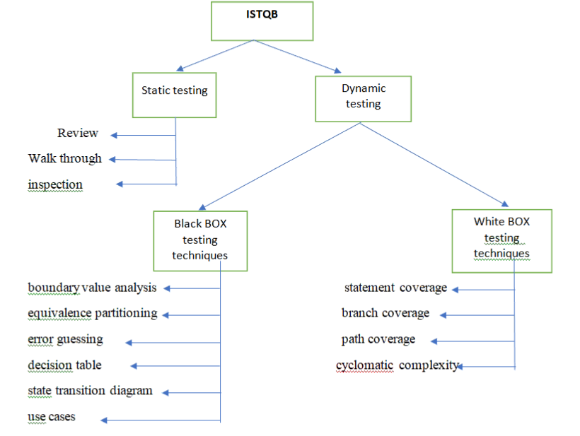

Static testing:

Testing which is performed on the documents is called static testing

There is no execution here.

Example: the document can be requirement, test cases, RTM, defect report etc

Types of static testing

Review:

Finding the mistakes in the document is called review

Here we have

Self-review: review done by us

Peer to peer: review done by other who are equal to us

Manager review: review done by manager

Walk through:

Explaining about the document to set of people who are not aware of that.

Example: we all have given walk through of our project in our college days.

Inspection:

This is kind of auditing processes which is done on the document of a software company.

ISO- international organization for standardization (it is for hardware)

Similarly

CMMI capability maturity model integrated (for software companies)

It has five levels CMMI 1, CMMI 2, CMMI 3, CMMI 4, CMMI 5.

Highest level is CMMI level 5

SEI: software engineering institute

CMMI is the recognition given by SEL

Path to get ISTQB question paper

Tryqa.com- ISTQB dumps/mock test – scroll down- we will get dumps & mock test foundation level paper.

Dynamic Test:

Testing which is done on the application is called dynamic testing.

That is on source code or UI of an application. Here in the testing execution happens.

Example: FI, IT, ST etc comes under dynamic testing

Black box testing techniques:

Boundary value analysis: it is technique use to list the boundaries of the components or elements present on webpages

Example:

1. REQ text field with 6- 20 characters

6 20

x y

x-1 x+1 y-1 y+1

5,6,7 19,20,21 (3value BVA)

5,6 20,21 (2 value BVA)

1. REQ text field with 100- 500 characters

99 -100-101 499-500-501 3value

99-100 500-501 2value

1. REQ 50-100

49,50,1 99,100,101 3value

49,50 100,101 2 value

49.9, 50, 50.1 99.9,100,100.1 decimal value

49.99,50,50.01 99.99,100,100.1 decimal value

1. REQ phone number field should accept 10 digits only

9 10 11 BVA

Equivalence partitioning:

It is also known equivalence class

It is a technique which is used to come up with some number by partitioning the requirement

Example

REQ text field should accept between 6 to 20 characters

6- 20

2 12 30

Invalid valid invalid

Valid- should be between the range

One invalid- should be below the lower ranger

One invalid- should be above the higher ranger

Error guessing:

It is techniques where we come up with negative scenario which is not covered in BVA and EP. The scenario what we find in error guessing, should give error messages in the application

We can get a greater number of scenarios based on experience

IT IS EXPERIENCE BASED TECHNIC

Example: text field should accept between 6 to 20 characters (Alphabets only) it is mandatory

123456 EM

@#$%^& EM

abcde@ EM

Blank EM

Note: This are tech mainly used for function testing, BVA will be used for text field only

Example: first name, email id, phone, address

Error guessing can be used for all components

Example: text field, radio button, check box, drop down etc

Decision table:

It is the technique which is in the form of a table which tells some rules or some decision. Based on some condition.

This is going to help us, coming up with a greater number of scenarios.

Example:

ISTQB question paper no. 1

From in question 10)

State transition diagram:

It is a technique which explains the req in the form of diagram.

Which contains different state.

This is going to help us, coming up with a greater number of scenarios.

Example:

ISTQB question paper no. 1

From in question 14)

Use case diagram:

It is technique where we can write the requirement in the form of diagram.

In this mainly we use the words actors and actions.

Actor are nothing but users and each actor have some actions.

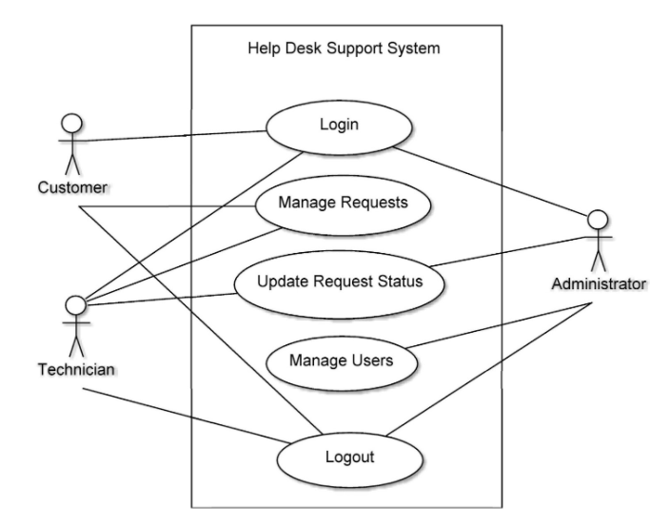

White box testing techniques:

ISTQB question paper 1 question n.27.

Read P

Read Q

If p+ q >100 then

Print “large”

End if

If p>50 then

Print “p large”

End if

Statement coverage

Test case 1: P=51, Q=50

Brach coverage

Test case 1: P=51, Q=50

Test case 2: P=50, Q=50

Path coverage

Test case 2: P=50, Q=50

8Test case 3: P=50, Q=51

Test case 4: P=51, Q=49

Conclusion: whenever a source code is written, we come up with flow chart. In the flow chart we need to identify statements, branches, path

We have to think, the test cases or scenarios for that flow chart and judge whether we are able to cover all statements, all branches and paths.

100% SC not= 100% BC not= 100% Pc 🡪 True

100% SC= 100% BC = 100% PC 🡪 false

100% Pc= 100% BC= 100% SC 🡪 True

Example: question paper no. 1

Question number 16)

Answer D

Cyclomatic complexity:

It is technique which is used to identify the complexity in a program

If source code is complex, even testing be complex. This CC will help to find complexity in the program.

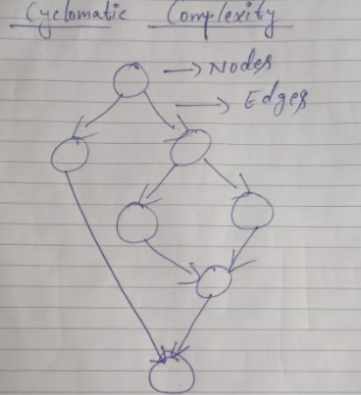

Formula 1 cc=(E-N) +2

= (8-7) +2

=3

Formula 2 cc= no of predicate Nodes +1

=2+1

= 3

(predicate node- a node which has 2 or more outgoing edges)

Formula 3 cc=no of regions +1

=2+1

=3

Formula 4 cc= number of paths =3

Types of regression testing:

Unit regression test:

Whenever a new feature is added for existing module and the impact is only for that particular module, we also call it as unit.

When we do regression testing for that unit, we do not do regression testing for any other unit that is called unit regression testing.

Example: I build number one we don’t have remember password but in build number 2 develop added remember password option. This will not affect that particular module not any other module.

So, we do regression testing for only that module. This is Unit regression testing.

Regional regression testing:

Whenever there is a change in one module which having dependency other few modules. But not all the modules in your application.

This module which are even partially dependent can be a region.

Performing regression testing on this region is regional regression testing.

Example:

Compose module in Gmail is dependent on, sent, draft and even inbox module.

When developer do a change in compose, we have to do regression testing on all dependent modules.

Full regression testing:

Whenever there is any change an application and because of that change if we have impact on the whole application then we do complete testing again for whole application. This is called full regression testing.

Note:

In the initial builds we can do until regression testing. In the middle of the testing phase, we usually do regional regression testing. At the end or before giving the application to customer we do full regression testing.

Requirement Traceability matric

Types of RTM

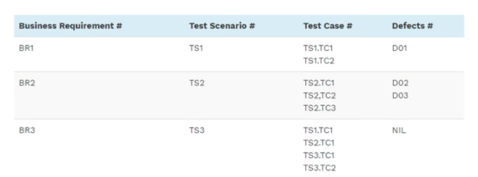

Forward traceability Matrix

Mapping from BASE document to DRIVED document

Ex REQ> SCENARIO>TEST CASE

Backward Matrix

Mapping from DERIVED document to BASE document

Test case> scenarios>REQ

Bi-Directional Traceability Matrix

Mapping from DERVID document to BASE document and mapping from DERIVED to another DERIVED document

EX scenarios >REQ

Scenario> test case.

USER ACCPETANCE TESTING:

It is a testing which is mainly done to check the business scenarios of the application which is done by the customer.

It is an end to end testing which is done by customer to ensure the application is fit for business scenarios or not.

Why acceptance testing is done?

This is mainly done to get a confidence for customer before he releases the product to the end user.

Because of business pressure, software company might be releasing the application to the customer with some defects. To ensure this is not there, customer will do acceptance testing.

If the product is released to the end user without checking the business scenarios, it will affect the customer business to avoid this, acceptance testing has to be done.

We may forget some of the business scenarios to test and those scenarios would be tested by customer.

If the customer finds the defect during the acceptance testing. That is negative to the test engineers.

So before giving application to customer. We should think all those business scenarios and find defects.

Approaches for UAT:

Approaches no 1: BA or IT Engineer of customer will do acceptance testing at customers’ place.

Approaches no 2: Employee or test engineer of customer will do acceptance testing at customer’s place.

Approaches no 3: Test engineer of software company will do acceptance testing at customer’s place.

Approaches no4: Test engineer of software company will do acceptance testing under control of customer at developer’s place.

Alpha testing and beta Testing are types of UAT

|  |  |
| --- | --- |
| ALPHA | BETA |
| Alpha testing is performed by tester who are usually an internal employee of an organization | Beta testing is performed by the client or end user who are not an employee of an organization |
| Alpha testing is performed at the developer site | Beta testing is performed at the client location or end user of product |
| Reliability and security testing are not performed in depth in alpha testing | Reliability and security and robustness are checked during beta testing. |
| Alpha testing involves both black and white box testing techniques | Beta testing uses black box testing techniques |
| Alpha testing requires lab environment or testing environment | Beta testing doesn’t require lab environment or testing environment because software is available for end user and is said to be real time environment. |
| Long execution cycle may require for alpha testing | Only few weeks execution are required for beta testing |
| Critical issues or fix are addressed by developers immediately in alpha testing | Most of the issues or feedback are collected from beta testing. Will be implemented in future version of the product |
| Alpha testing ensures the quality of the product before moving to the beta testing | Beta testing also conducted on the quality of the product but gathers user impact on the product and ensure that the product id read y for real time environment. |
| Virtual environment | Real time environment |
| Off shore | On site |
| Alpha testing is done under controlled environment | Beta testing is done under uncontrolled environment |

After acceptance testing, if everything is fine production release will happen.

Hotfix / incident management system

When the software company releases the product to customer. If the end user or customer finds any defect in the software. Customer will raise an incident to software company and software company should fix the defect as early as possible and give back to the customer. This is called hotfix.

If any problem is find by the customer or end user in the production server , it will be raised as an incident to the software company. Every incident is in the form of Ticket and every ticket has its priority.

This commitment between software company and customer is called as server level agreement. SLA

Ex

PRIORITY OF TICKET TIME GIVEN TO FIX

P1 3hr

P2 10hr

P3 1day

P4 10days

Note:

Hotfix happens only after production release, if there is any issue in production server.

THIS IS BAD SITUATION FOR A SOFTWARE COMPANY

(people will lose job)

FISH BONE DIAGRAM / ISHKAWAN DIAGRAM

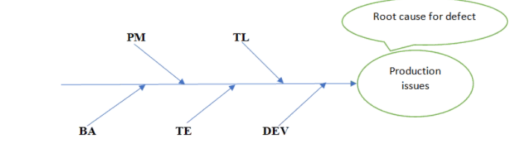

Whenever there is production issue all the team members will gather together, and they discuss about reason for production issue that is document in the form of fish bone diagram. the main purpose of this is to find the root cause of the production issue

SHORT TREM RELEASE/ INTERIM RELEASE

Between two planning release of an application, some times customer gives a unplanned release which is done in short duration. It I short term duration.

Short term release:

REQ (A1) march 1st – march 31st

REQ (A1-a) march 15th – April 15th STR

REQ (A2) April 1st – April 30th

SIT:

testing the data flow between, two are more systems.

Example: whenever we get a friend request in Facebook, we usually get notification in Gmail. Here Gmail and Facebook are two independent system.

To test if we get correct notification to correct account it is called SIT.

TEST BED:

It is a platform or environment or layer where we test the application.

Sometimes it is also referred as test data.

Example: if I am testing WhatsApp in android mobile then android can be test bed.

PRINCIPLES OF SOFTWARE TESTING:

Testing shows presence of defect:

Testing software application will help us to find the defects and make software bug free. Before providing to customer.

Exhaustive testing is not possible:

We should always do optimised testing because exhaustive testing is over testing and may consume your lot of time and efforts.

Early testing:

We should always do early testing because finding the defect at early stage is better. It will save your time and effort.

It is actually a static testing

Defect culstrating:

According to research 80% of defects are found in 20% of module. We should always find cause defect.

Pesticide paradox:

When we use same type of testing again and again, we can’t find more defects. We have to change way of testing.

Testing is context dependent:

We should test different application in different ways.

* Absence-of-errors fallacy::

Even through application is bug free. If we have tested for wrong requirements. It is unusable.

Water fall model:

It is one of the oldest traditional models.

Why we go for water fall model?

1. When the customer freezes the requirement (doesn’t change)
2. For any short- term project.
3. For developing simple application.

What are the advantages of waterfall model?

1. We can expect stable application
2. There will be no disturbance for the team members if the requirement does not change.

Drawback of waterfall model?

1. Testing happens after coding.
2. Requirement and design are not tested
3. Developer used to do testing before currently it is done by test engineers.
4. If requirement changers it leads to lot of rework.

Why developers are not involved in testing?

1. Developers always focus how to build the software not to break the software.
2. They always be over confident what they do
3. They do not like to find their own mistakes
4. Since it is not easy to find their own mistakes.

Spiral model:

We do we go for spiral model?

1. When the customer gives requirement part by part
2. When there is a lot of dependence b/w the module.

What are the advantages of spiral model?

1. Customer can see the application partially and can get confidence.
2. Requirement changes can be done.

What are the drawbacks of the spiral model?

Requirement and design are not tested.

Testing happens only after coding.

V and V model:

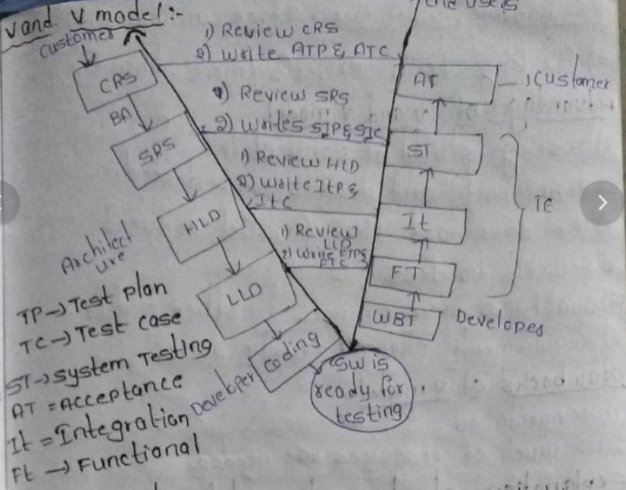

V and V means verification and validation model

Verification is process of checking “are we building product right”

Validation is a process of checking “are we building right product”

V and v are done only by test engineer

Verification is QA

Validation is QC

When do we go for V and V model?

1. When the customer needs high quality product.
2. For complicated application

Ex: building heath, banking space application.

1. For long term project

Advantages of v and v model.

1. Testing starts at initial stage.
2. Requirement and design are tested
3. Down word flow of defect decreases
4. Requirement changes can be done.
5. Quality will be high compare to other models
6. Rework will be less.

Drawbacks of V and V model.

1. Documentation work will be more
2. To much of resources are required

Prototype model:

Prototype is a dummy model that is a non-working application

When we go for prototype model?

1. When the customer is not clear about requirement
2. When the software company is new to the domain then they will go for protype model.
3. When the developer are new to the technologies it is experimentation model.
4. When the customer and software company are new to the business.

Advantages of prototype model:

1. Initially customer can get to know what he gets on.
2. Initially developer will also come to know what they should delivery last day
3. Requirement changes can be done initially stage.
4. Initially investment is very low

Drawback of prototype model

1. They will be delay in actual start of real project
2. Investment is done on non-working product
3. Too many changes can disturb the rhythm of the company.

Note: once, I get a job I will be working for any one of this model or combination of this models (hybrid model)

Or come up with new model form this mode (derived model) or I don’t know for which model. I’ll be working for.

Explain Academic project?

While explaining things focus on below things.

1. Tell the title (name of the project)
2. What is the purpose of that?
3. Who can use it?
4. Use the word “we” while explaining (this shows that we are team player)
5. Show case that I am the team lead
6. Flow should be very good
7. Confidence”
8. Communication
9. Link it to any one sdlc models.